**Project - 1**

**Configure and connect a MySQL Database Instance with an auto scaled EMS Web Server**

**DESCRIPTION**

You are working as a database administrator for an IT firm. You have been asked to create a new database instance on AWS cloud and connect it with the employee management portal hosted on a web server.

**Background of the problem statement:**

Your organization wants to deploy a new multi-tier application. The application will take live inputs from the employees, and it will be hosted on a web server running on the AWS cloud.

The development team has asked you to set up the web server and configure it to scale automatically in cases of a traffic surge, to make the application highly available. They have also asked you to take the inputs from the employees and store them securely in the database.

**The following must be used:**

* Create a Database Instance with the following specifications:
  + Database creation method: Standard Create
  + Engine: MySQL
  + Database Instance size: db.t2.micro

* Create an EC2 Instance with the following specifications:
  + AMI: Amazon Linux
  + Region: Use only US East (N Virginia), us-east-1, and us-east-2
  + Instance types: t2.micro and t3.micro
  + Allowed EBS types: GP2 and Standard

**Following requirements should be met:**

* Follow the above-mentioned specifications
* Make sure that the Availability Zone is similar throughout the instances and volumes
* Ensure that the server scales automatically and the traffic is optimally routed among the scaled servers
* Document the step-by-step process involved in completing this task

**AMAZON WEB SERVICES**

Amazon Web Services (AWS) is a suite of cloud computing services that allow organizations to store, process, and analyze data at speeds that matter. AWS provides compute, storage, networking, database, analytics and machine learning services across the globe.

**MYSQL RELATIONAL DATABASE SERVICE**

[MySQL](https://aws.amazon.com/rds/mysql/what-is-mysql/) is the world's most popular [open source](https://aws.amazon.com/products/databases/open-source-databases/) relational database and Amazon RDS makes it easy to set up, operate, and scale MySQL deployments in [the cloud](https://aws.amazon.com/what-is-cloud-computing/). With Amazon RDS, you can deploy scalable MySQL servers in minutes with cost-efficient and resizable hardware capacity.

Amazon RDS for MySQL frees you up to focus on application development by managing time-consuming database administration tasks including backups, software patching, monitoring, scaling and replication.

**LOAD BALANCER**

Load balancers can help you get the most out of your AWS resources.

Load balancing is a process that distributes traffic across multiple servers, so that each server is used only for the time it's needed. With load balancers, you can use the same code on multiple servers and add or remove servers as needed.

You can set up load balancers to distribute different types of workloads across multiple servers, such as requests for web content or database queries.

**AUTO SCALING**

Auto scaling is a feature that allows AWS to automatically scale up or down in response to changes in load.

Auto scaling will adjust the number of instances automatically based on changes in traffic. This can be useful for applications that have high peaks and short durations of user activity, as well as for applications that don't require constant access to the same amount of resourc

Initially I had loged into the AWS console.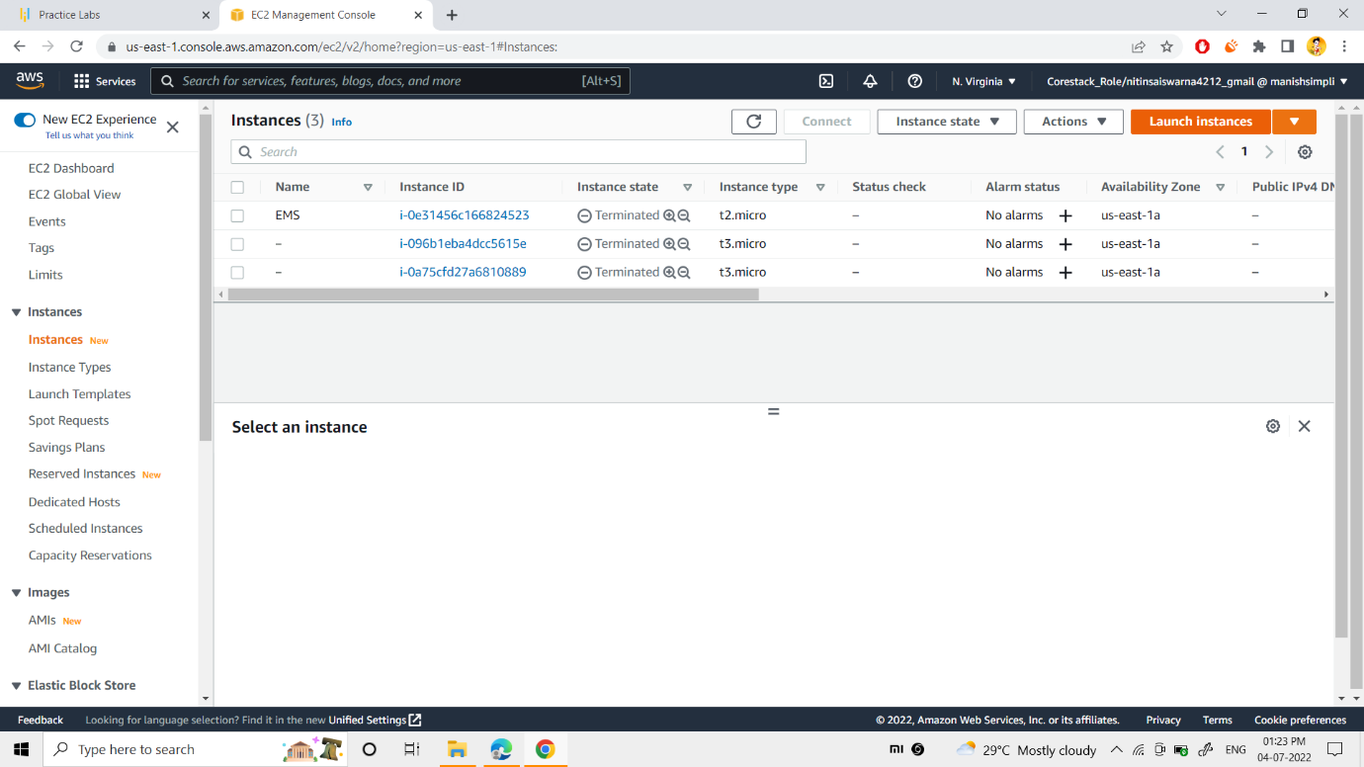

After login, I searched for the service “EC2” and then landed into the EC2 Instances page.

Initially, I launched the web server by clicking on the “Launch Instace” button.

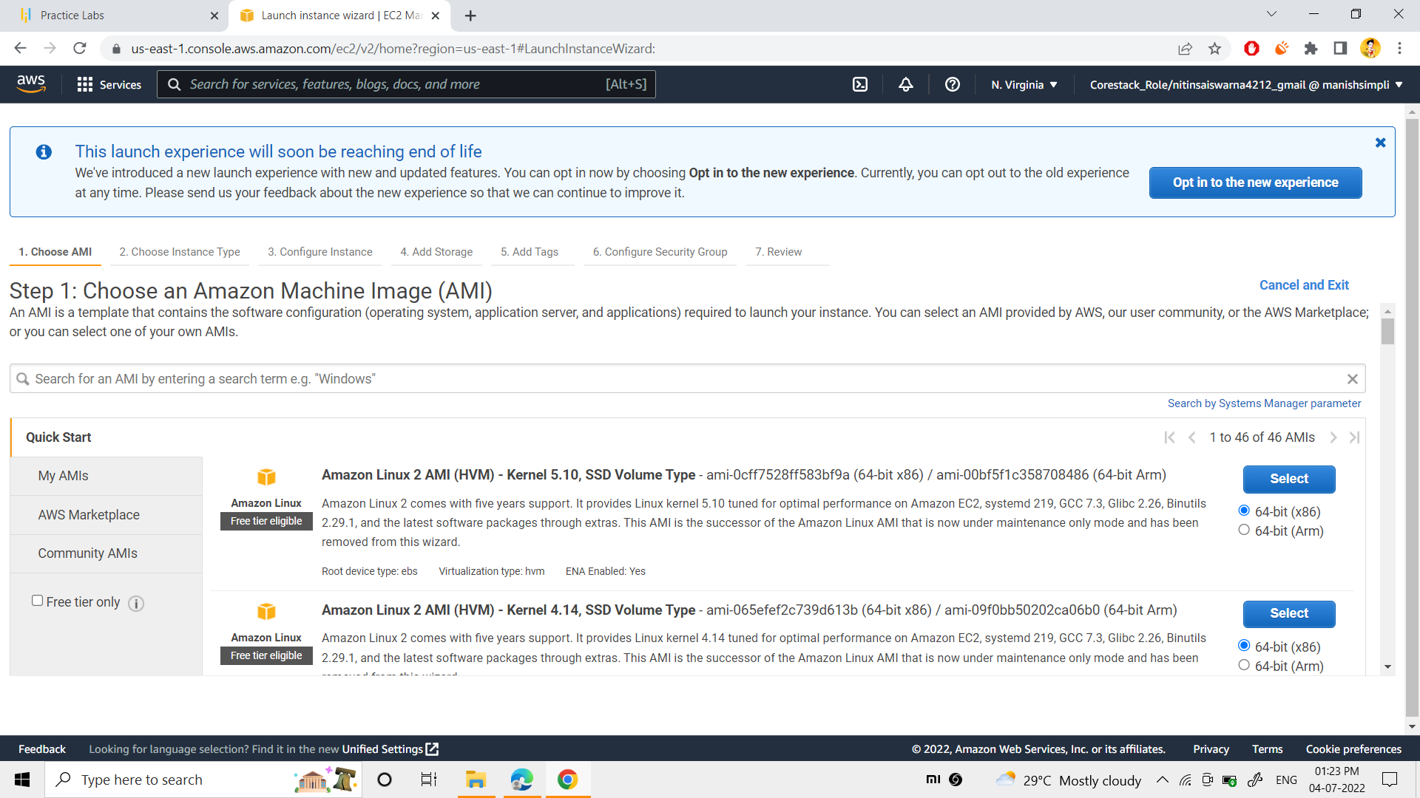

Later as step 1, “Amazon Linux 2 HVM” was chosen as my Amazon Machine Image(AMI).

Next I moved into the “Choose an instance type” as step 2.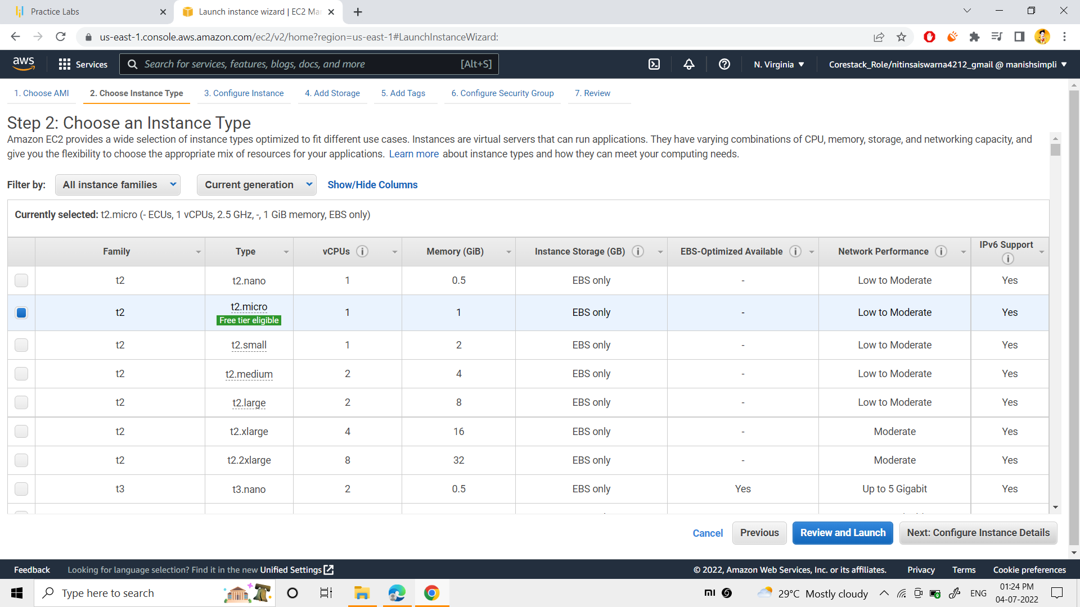

As the step 2,I selected the “t2.micro(free tier eligible)“as my Instance type.

Next I moved to the “Configure instance”

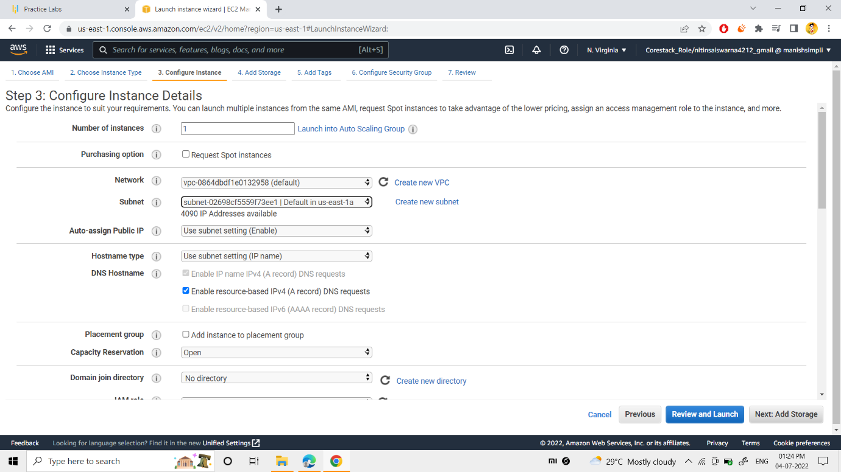

As step 3, I selected the vpc and subnet as vpc: -“default vpc” subnet: -“default in us-east-1a”.

Next, moving to the storage option.

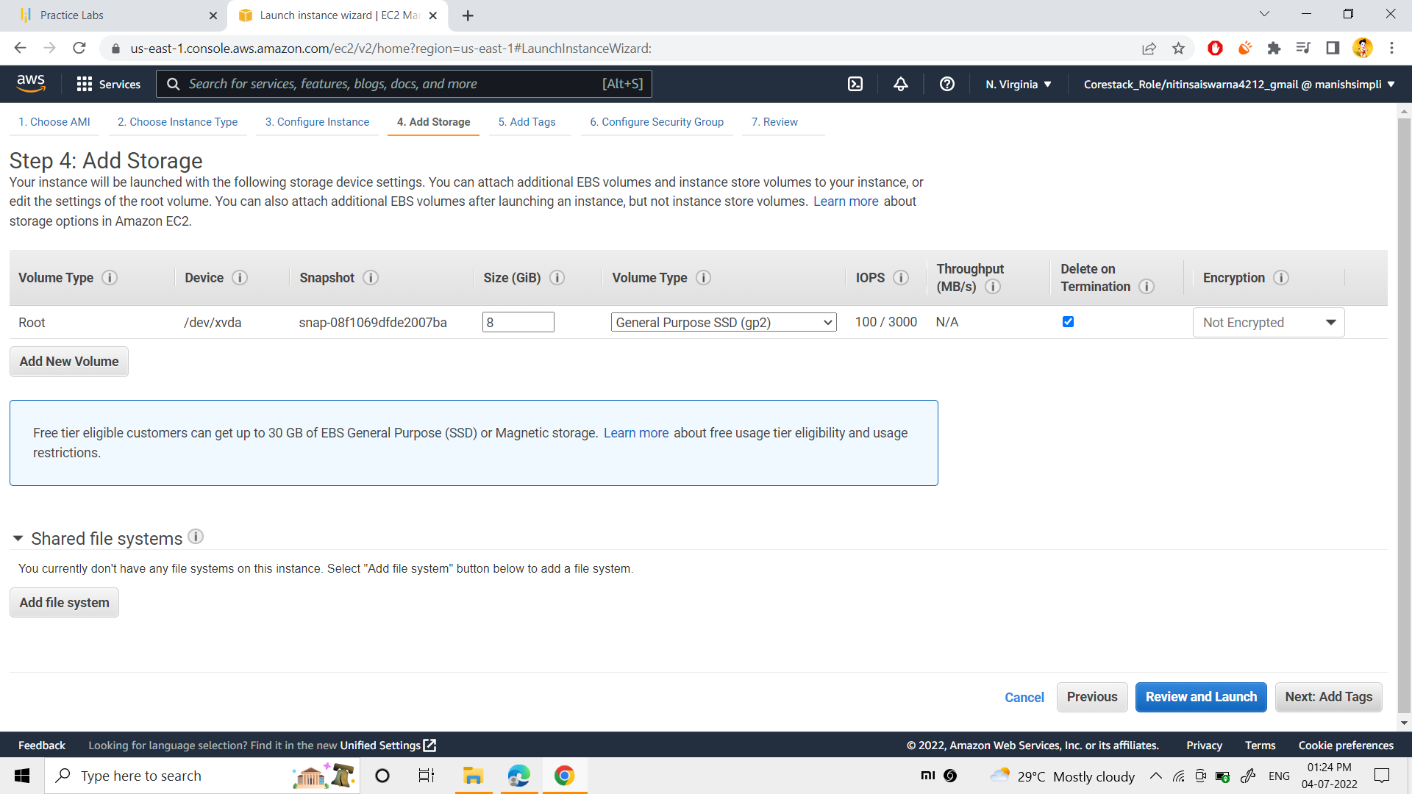

As step 4, I selected the volume size as “8GIB” & volume type as “general purpose ssd (gp2)”

Next “tag name” was added to my “EMS” server.

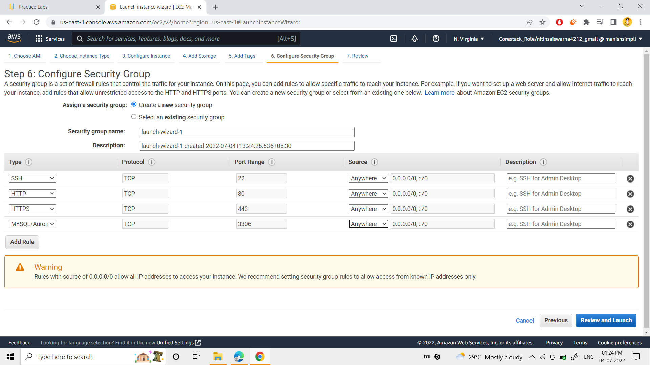

As step 6, I created a “new security group” such as SSH,HTTP,HTTPS,MYSQL/AURORA as per above snap.

Finally, moving to the review option,

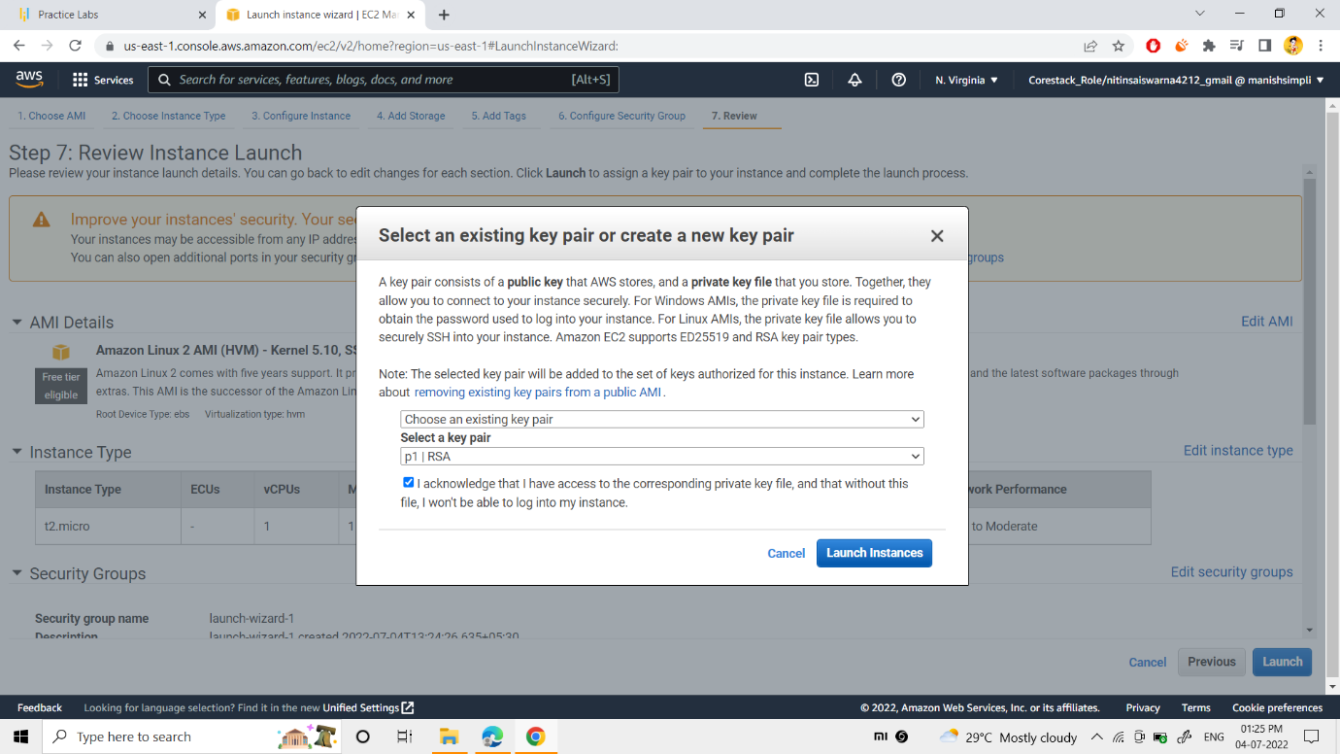

next proceeded with my “existing key pair”.

Ultimately, “Launch the instance”button was clicked. 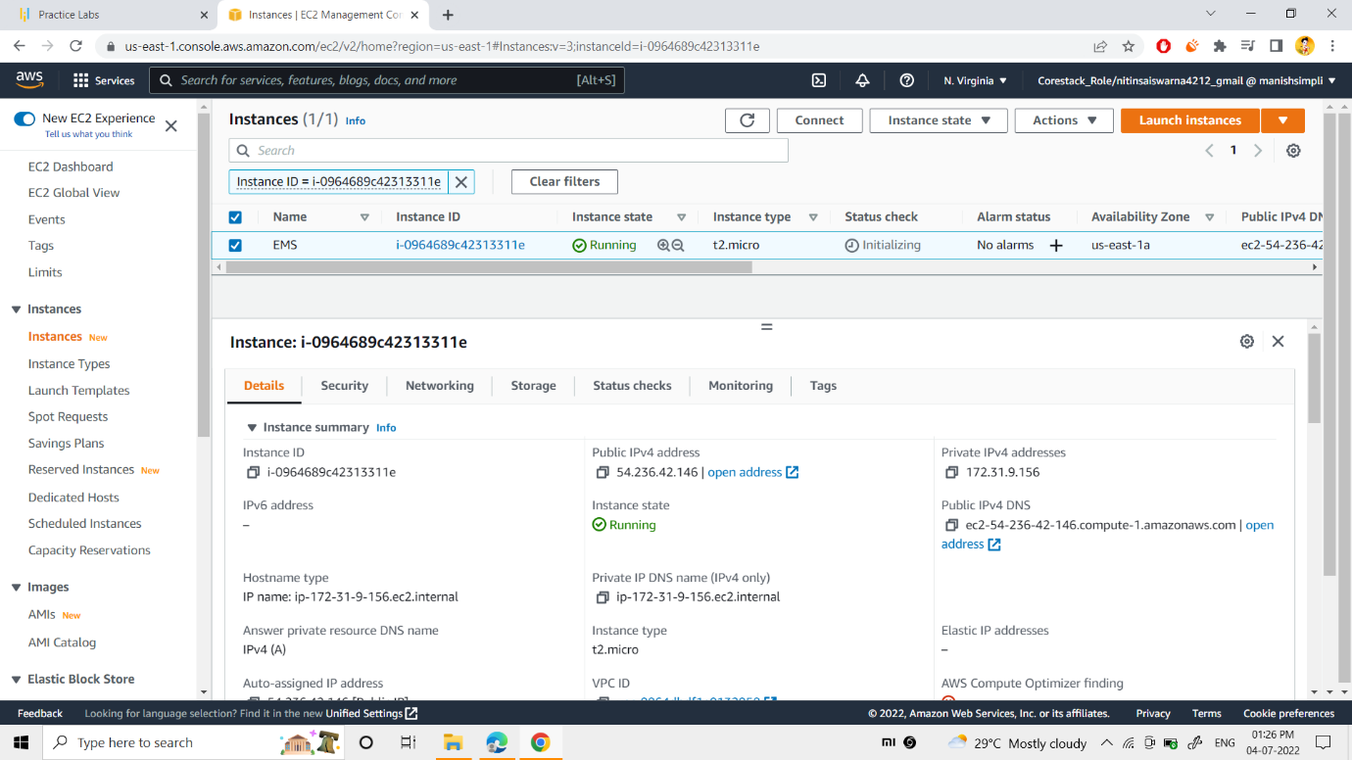

As per above snap, now my instance named “EMS” was created.

You can view the details too.

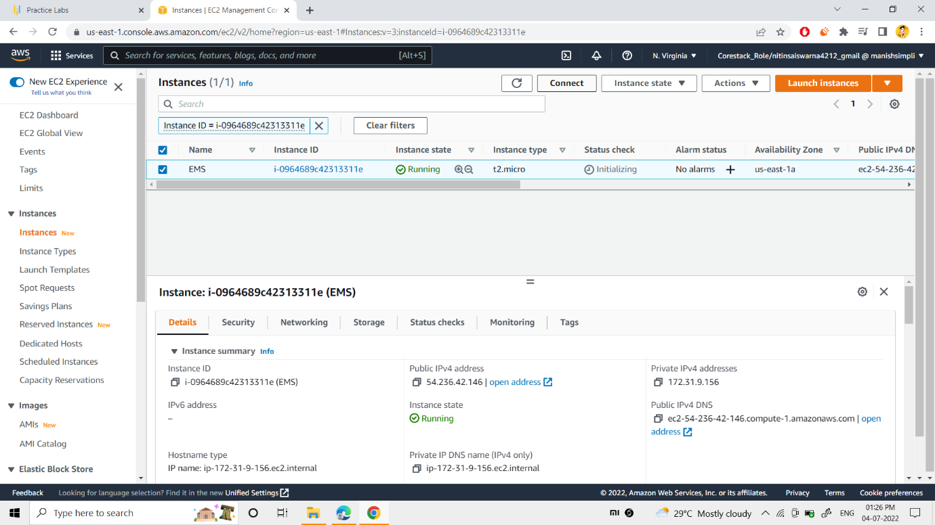

Now, connected to the EMS CLI(Command Line Interface) by clicking the “connect” button.

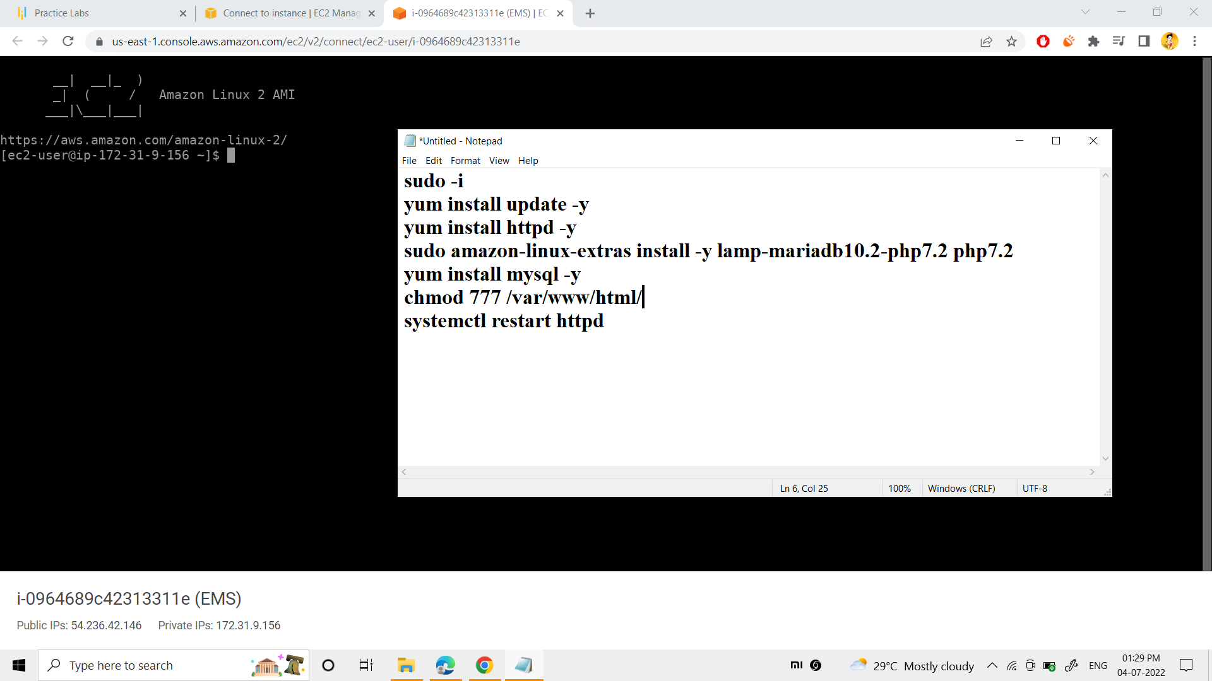

Now, commands were written as provided above in the notepad. The commands are used to install the

1)httpd web server

2)mariadb and php version 7.2

3)mysql database

Finally, the permissions to the html folder was given, to deploy the files. Later the httpd server was restarted.

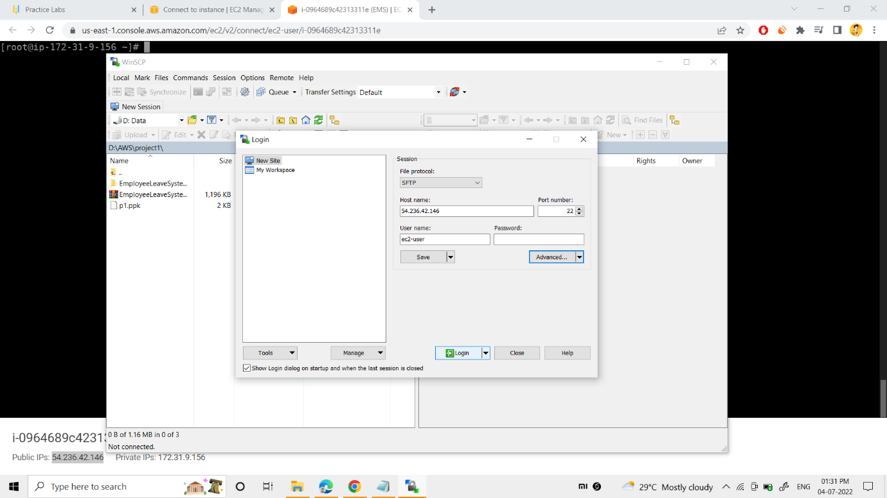

Now , I used the “WINSCP” application and connected to the ec2 server by giving its host name as public ip(54.236.42.146), user name as “ec2-user” and providing the key pair of EMS.

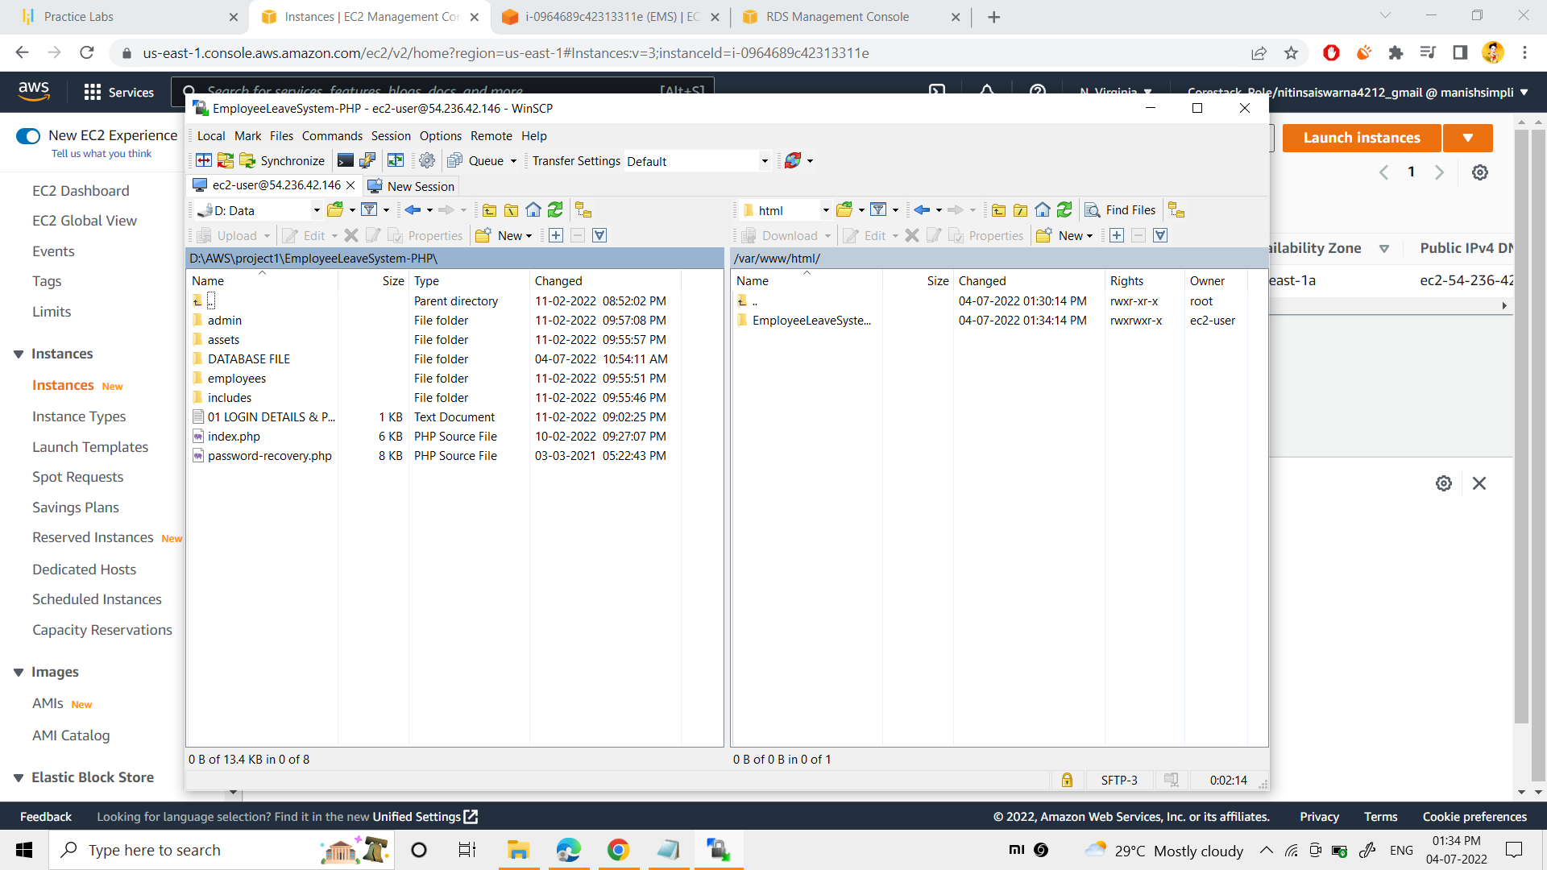

Later connecting into the winscp, transfered the files/folder(EmployeeLeaveSystem) from my local system into the server path as /var/www/html/.

Here you can find the link to download my web project :-

https://github.com/Jayavardhan-swarna/AWS-EMS-P1.git

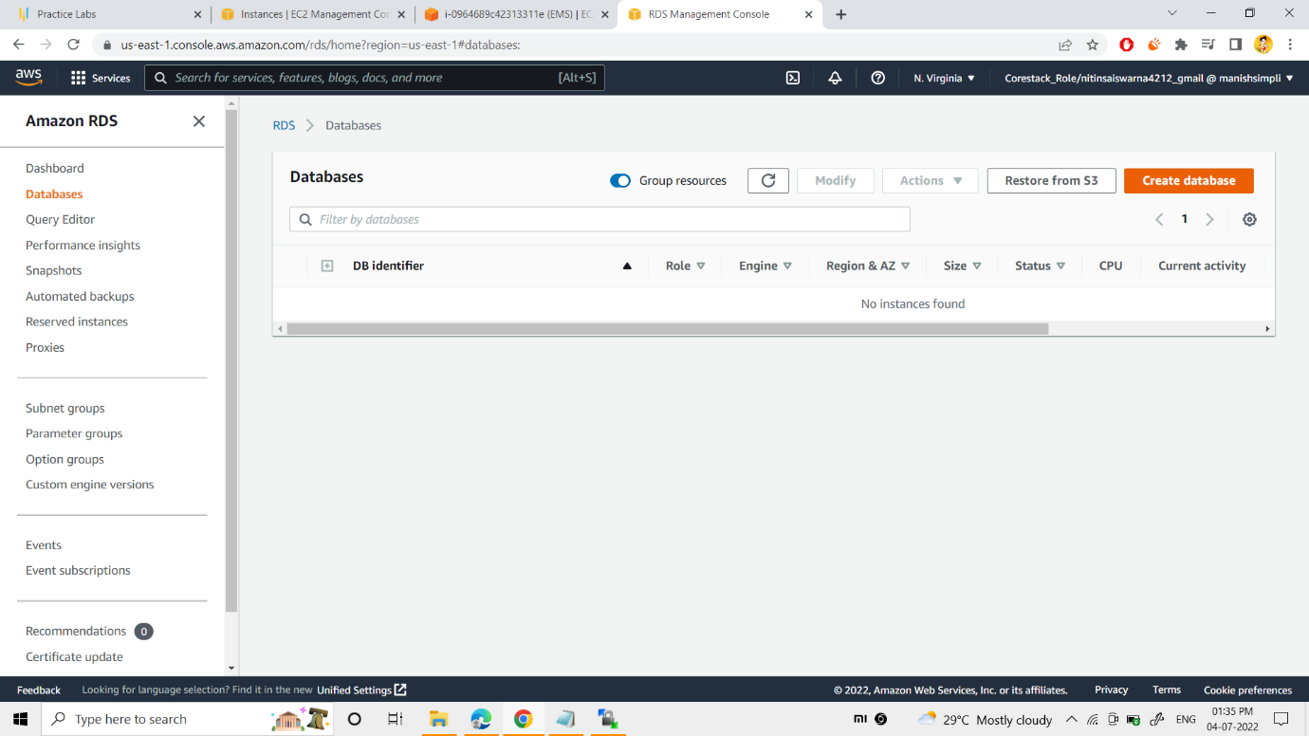

Next, searched for the service “RDS”, to create the database and connect with ec2.

To create the database, I clicked on the “create database” button.

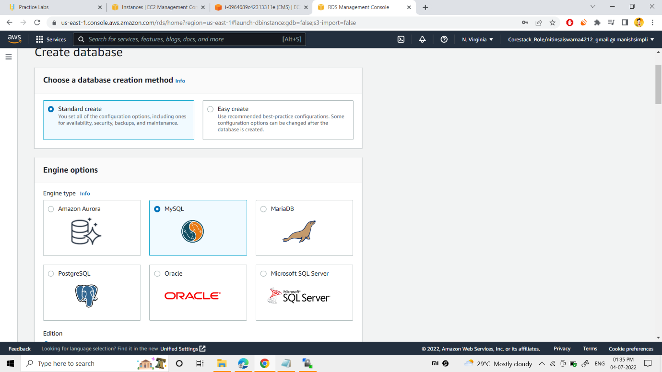

“Standard create method” was selected

Next “MYSQL” database engine was selected.

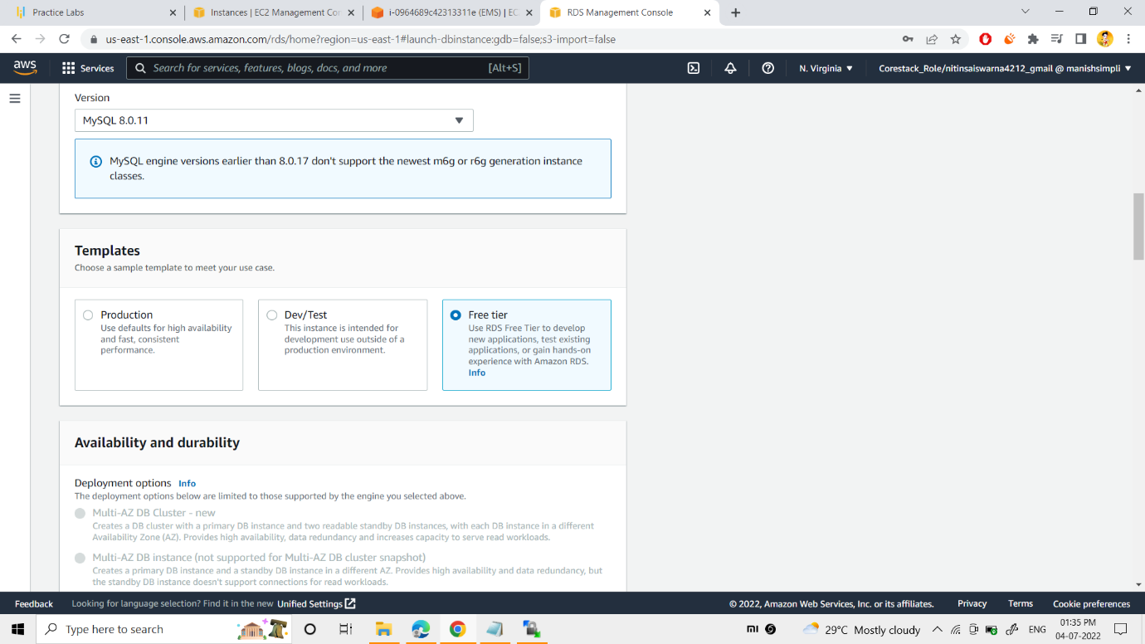

Now, I selected the mysql engine version as “8.0.11”.

Next “Free tier sample template” was chosen

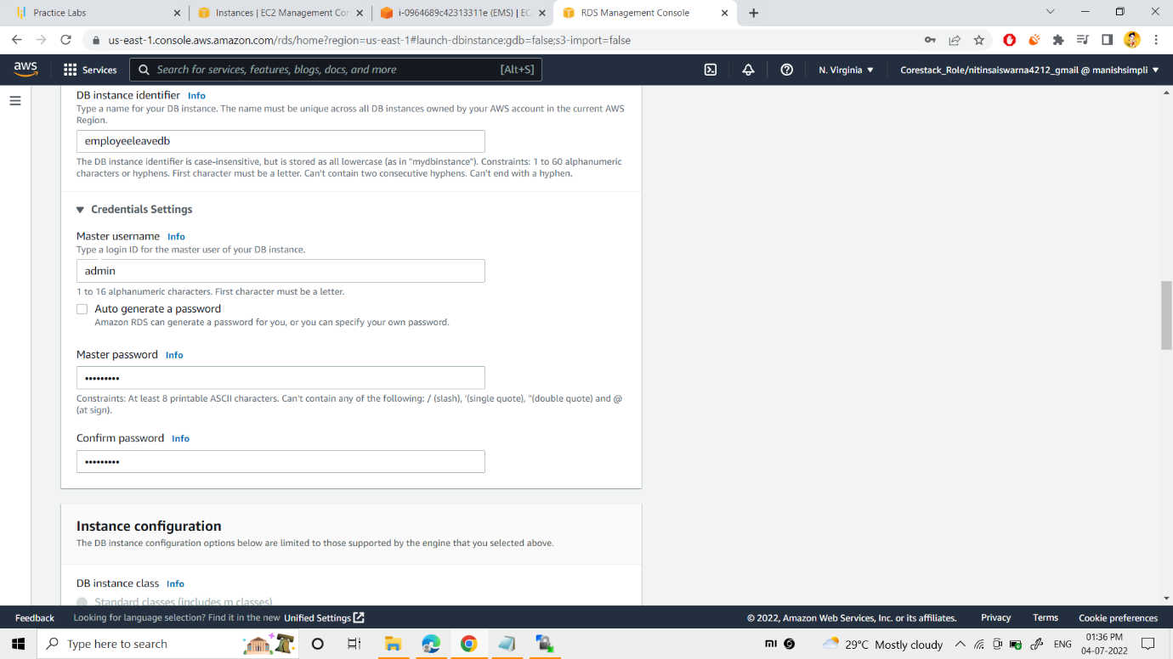

Now, database server was named as: - “employeeleavedb”.

Given the database username as: - “admin”.

Next database password “*********” was given.

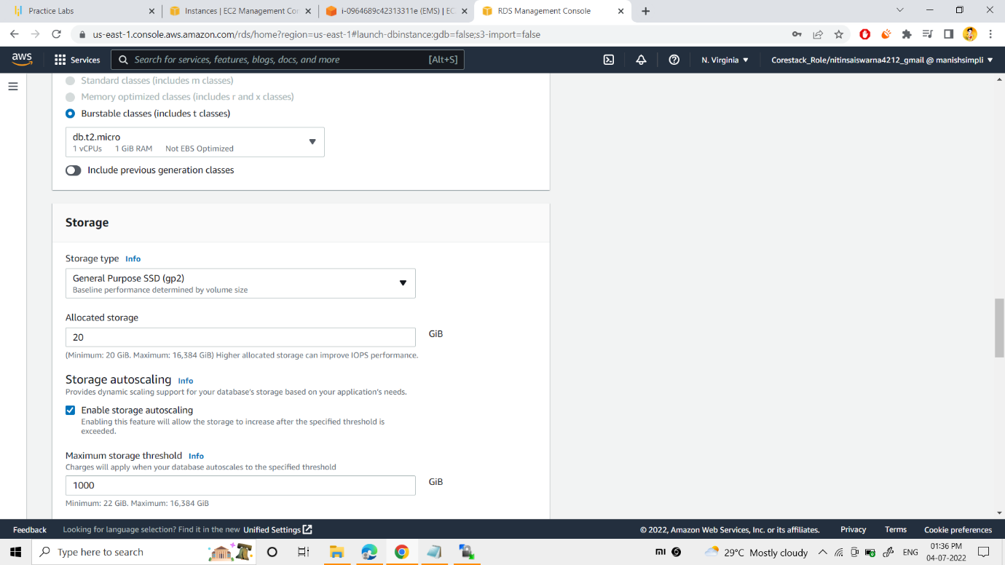

Now, “db.t2.micro” generation was chosen as per the instruction given.

Next, enabled the storage autoscaling option

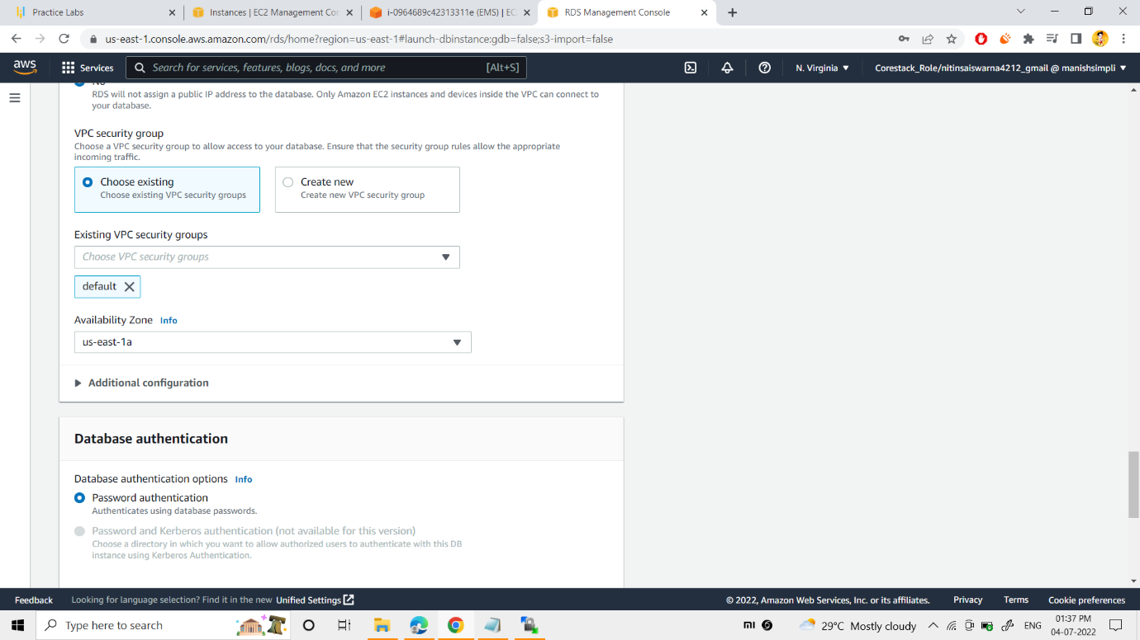

“Default” vpc security group was chosen.

“US-east-1a” availability zone was chosen as per the given instruction.

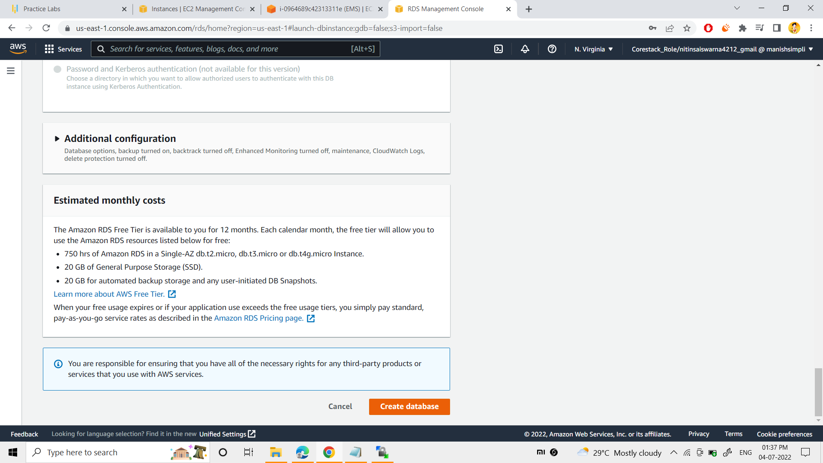

Finally, “create database” button was clicked.

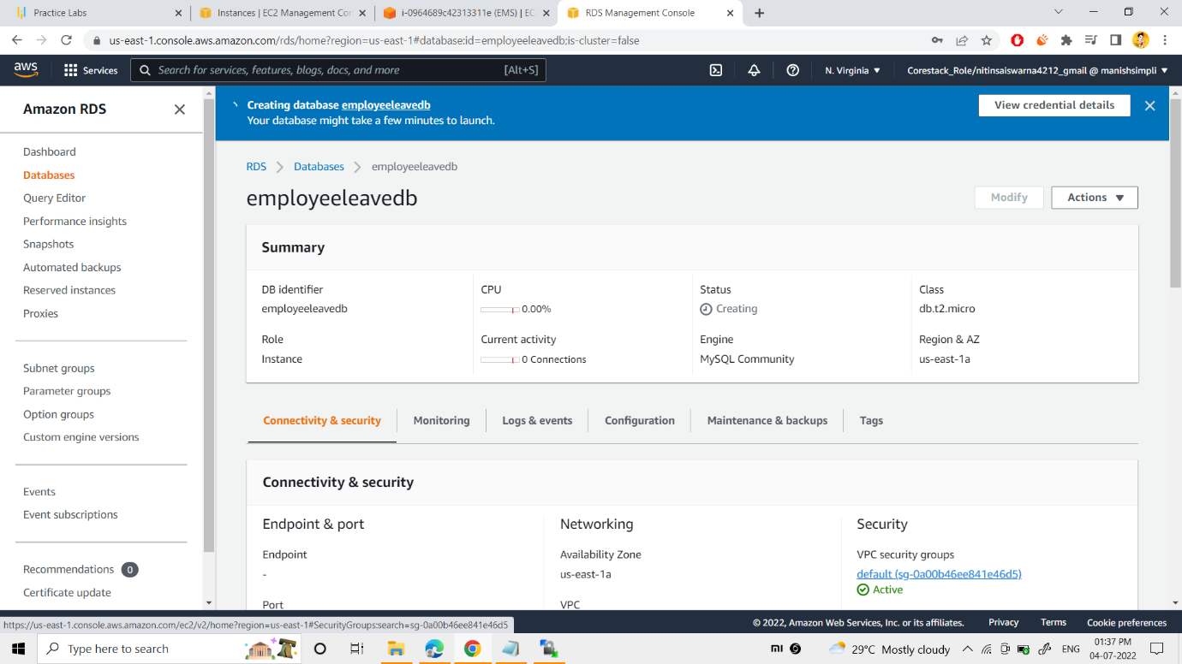

Ultimately, the database was created.

you can see the details too.

Now, I had gone into the vpc security group of the database that was created.

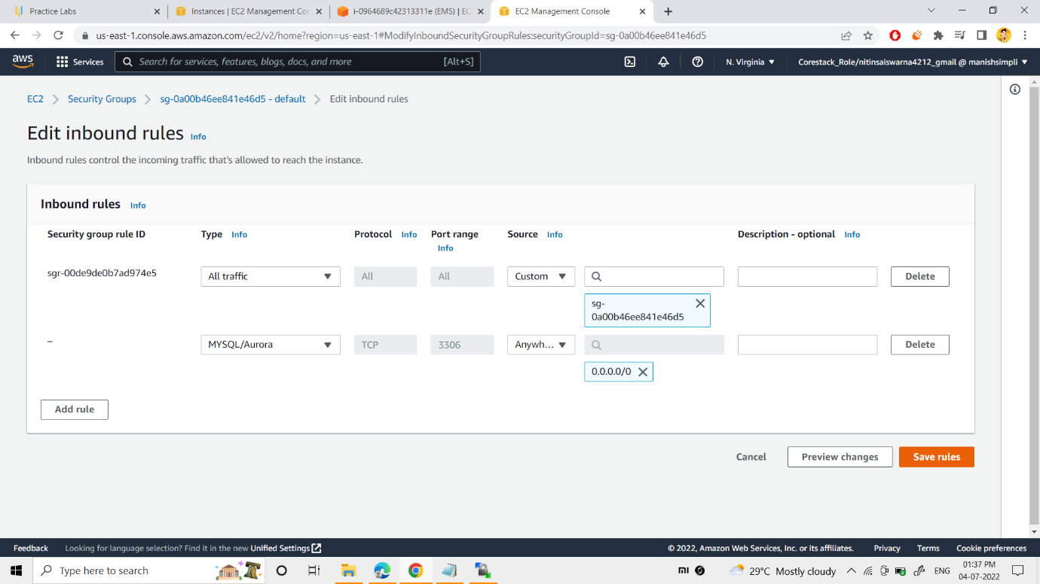

MYSQL/Aurora security group was added up, which contains 3306 port, as per the above snap.

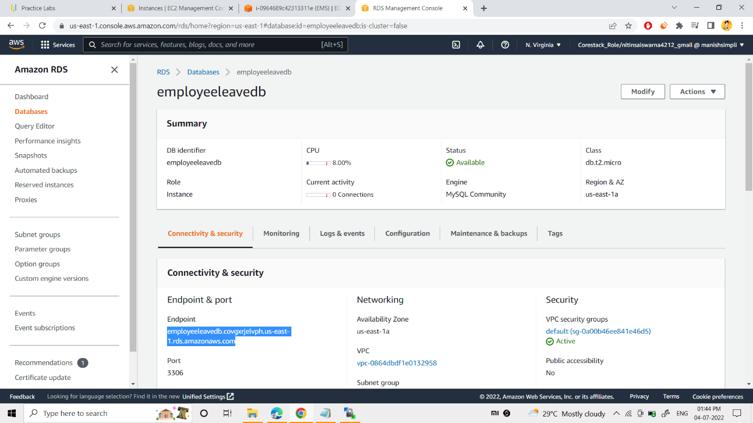

Now, I noted the endpoint of my database.

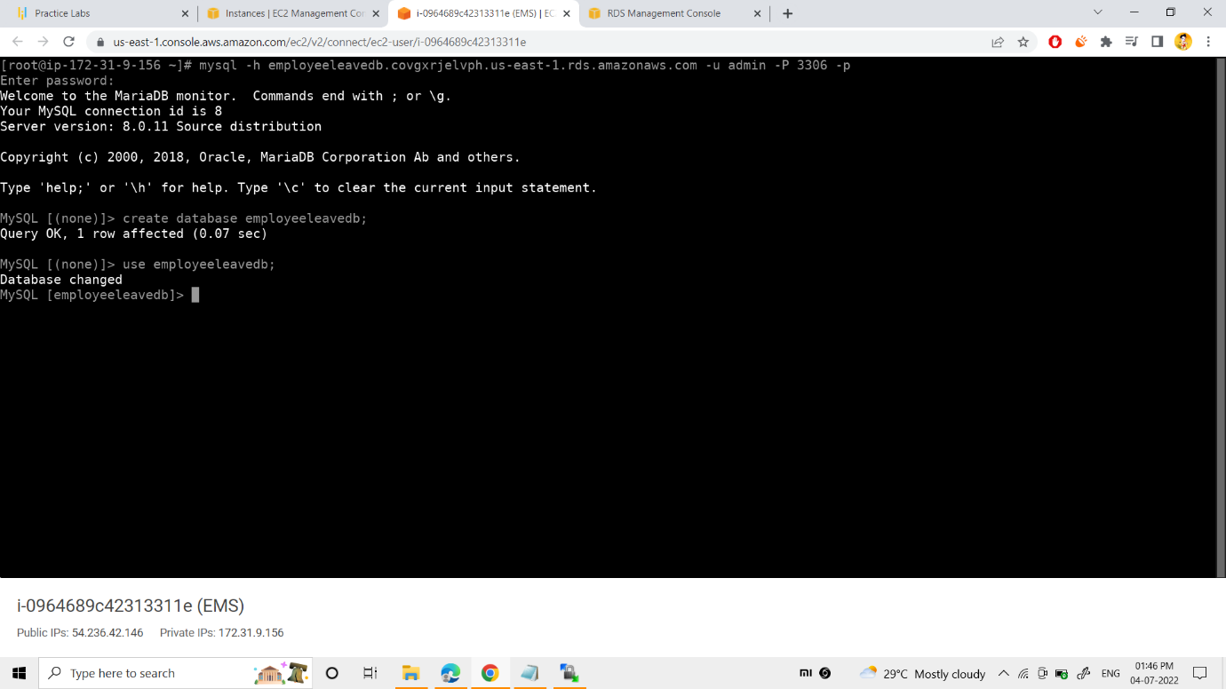

Now, to connect my database with my ec2 instance, I added up the 1st command as per above snap.

Now “employeeleavedb” was created and used up.

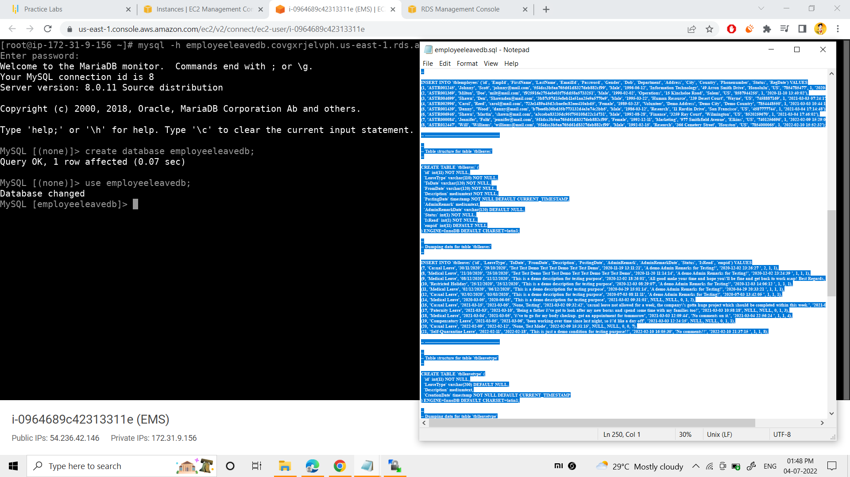

Now, I had given all the SQL commands that are needed to my project.

Here you can find the link to download my web project :-

https://github.com/Jayavardhan-swarna/AWS-EMS-P1/blob/main/EmployeeLeaveSystem-PHP/DATABASE%20FILE/employeeleavedb.sql

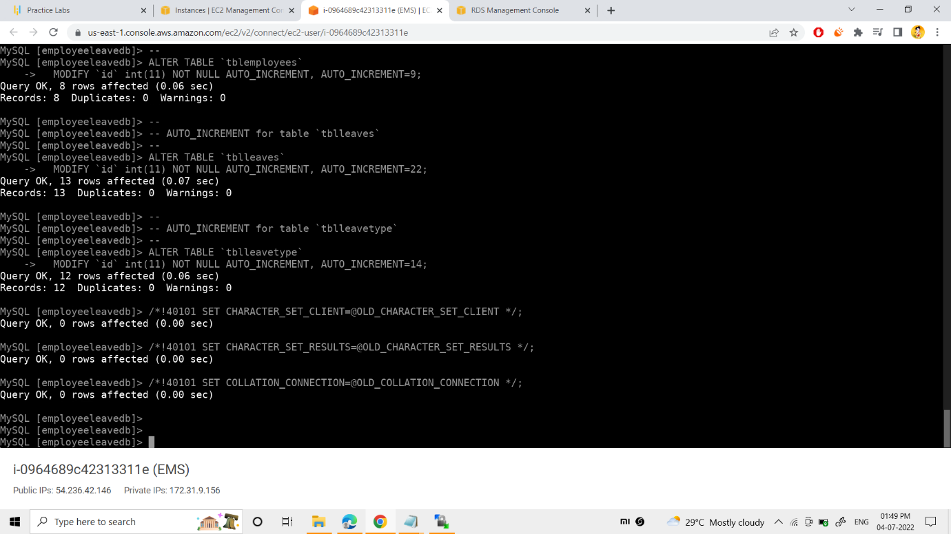

Here I added all the required SQL commands for my project.

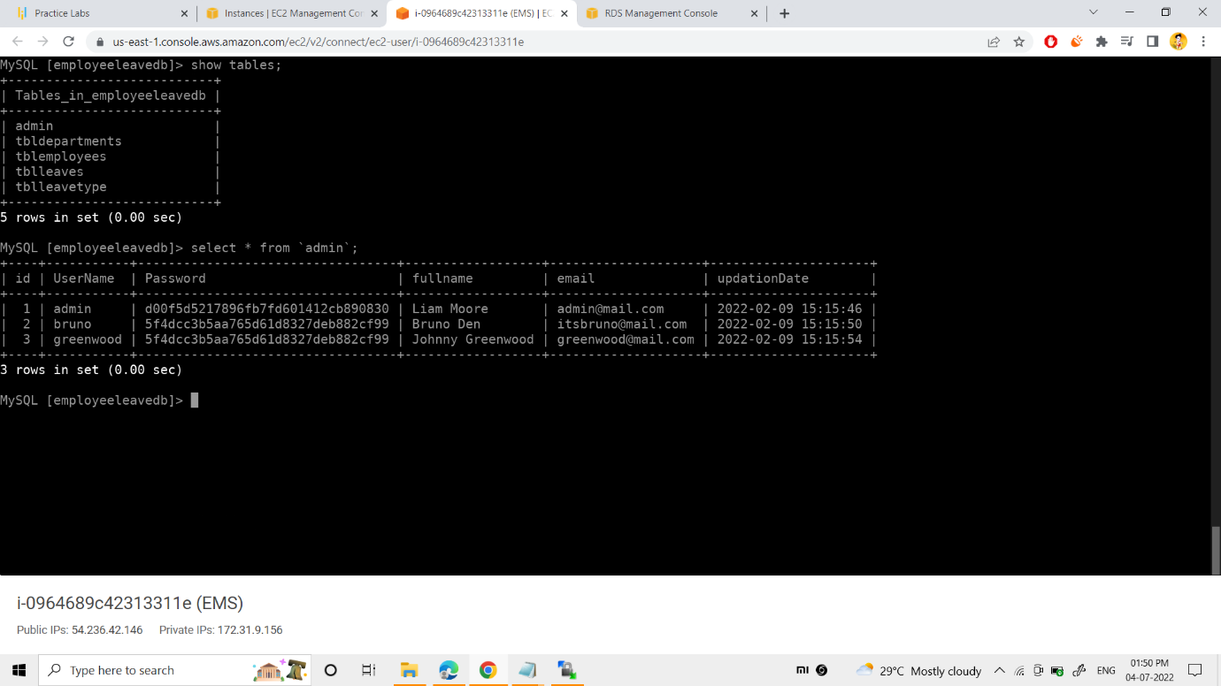

You will see my tables and the data that were created.

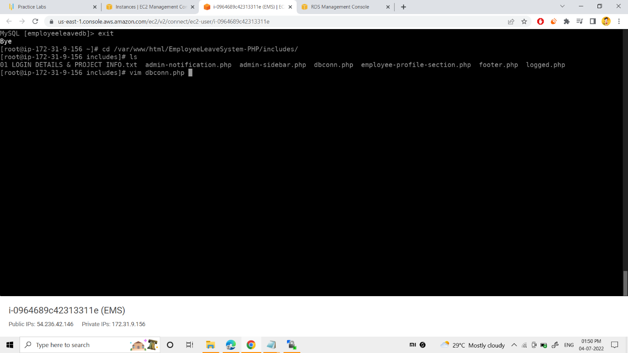

Now, to link my RDS Database with my project, dbconn.php file was edited with below snap

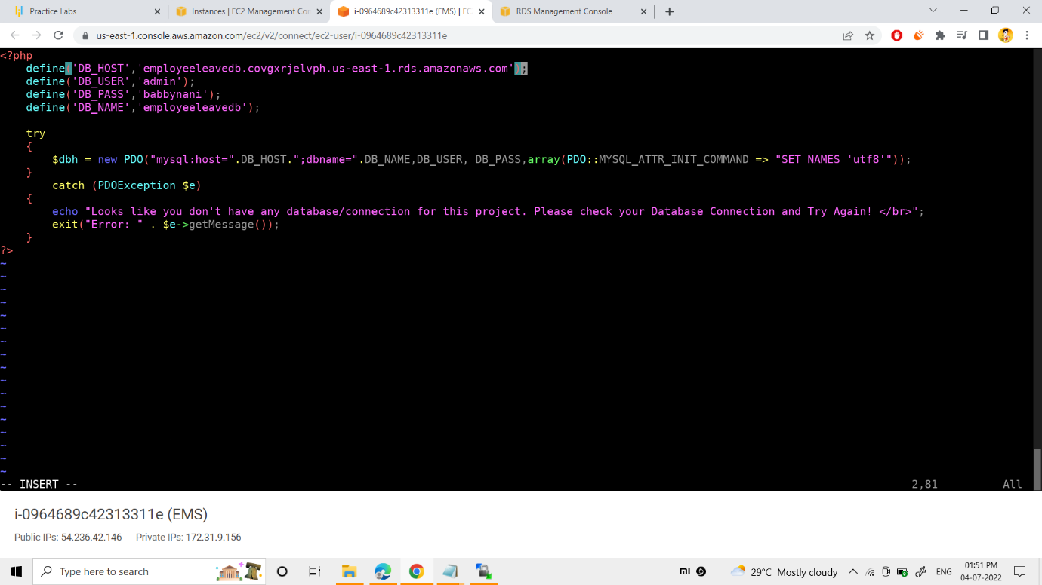

All the details of my RDS Database was given into the dbconn.php, such as

* + 1. host was replaced with aws endpoint
    2. username was repalced with aws database master username
    3. password was replaced with aws database master password

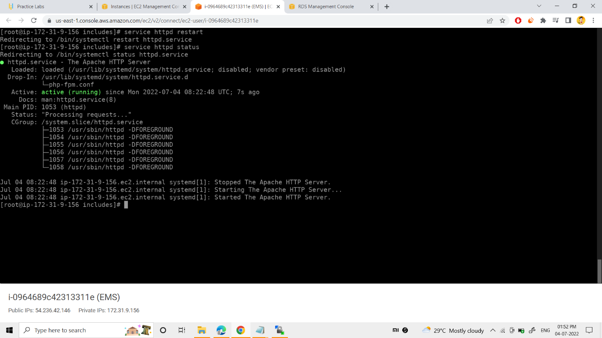

Httpd service was restarted and status was checked.

Now I copied the public ip of the server and I browsed it

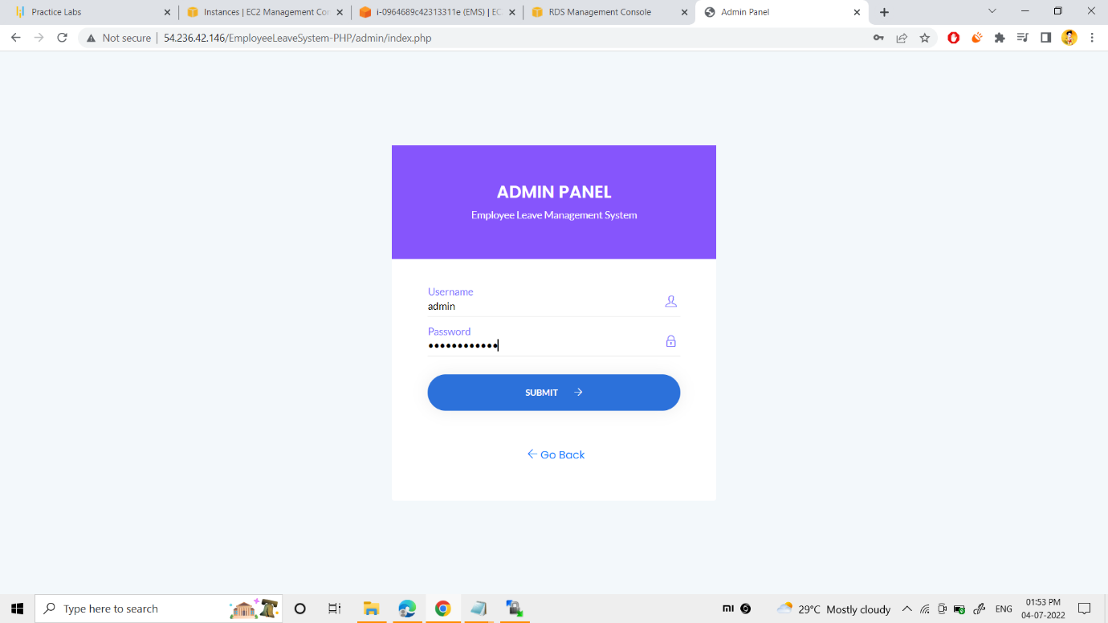

The result is shown in the above snap.

As an admin,I logged into my EMS website by providing the required credintials.

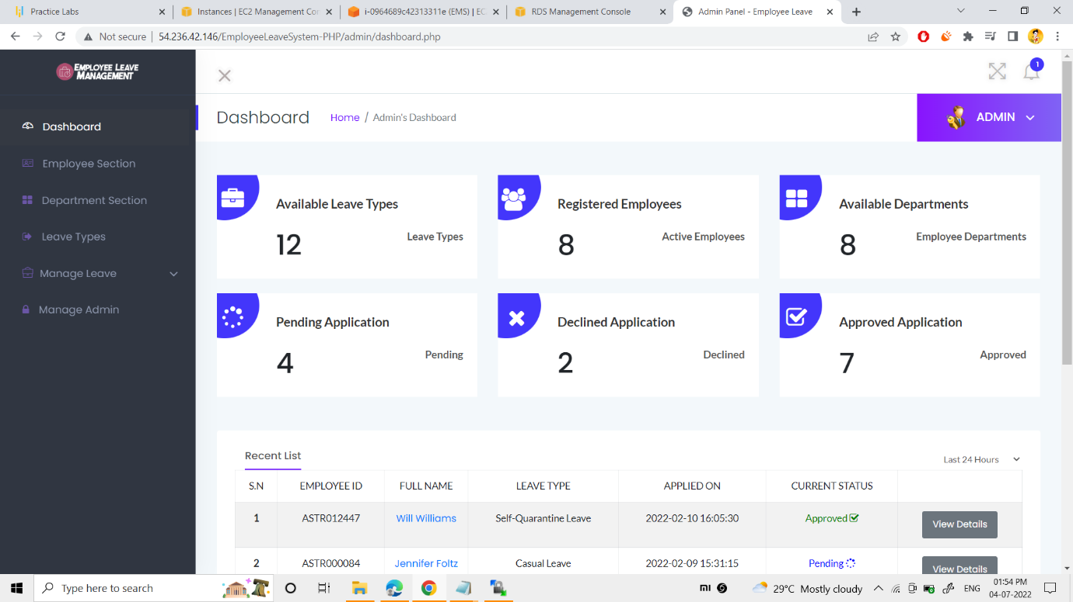

Now you can see my admin page controls and its specifications.

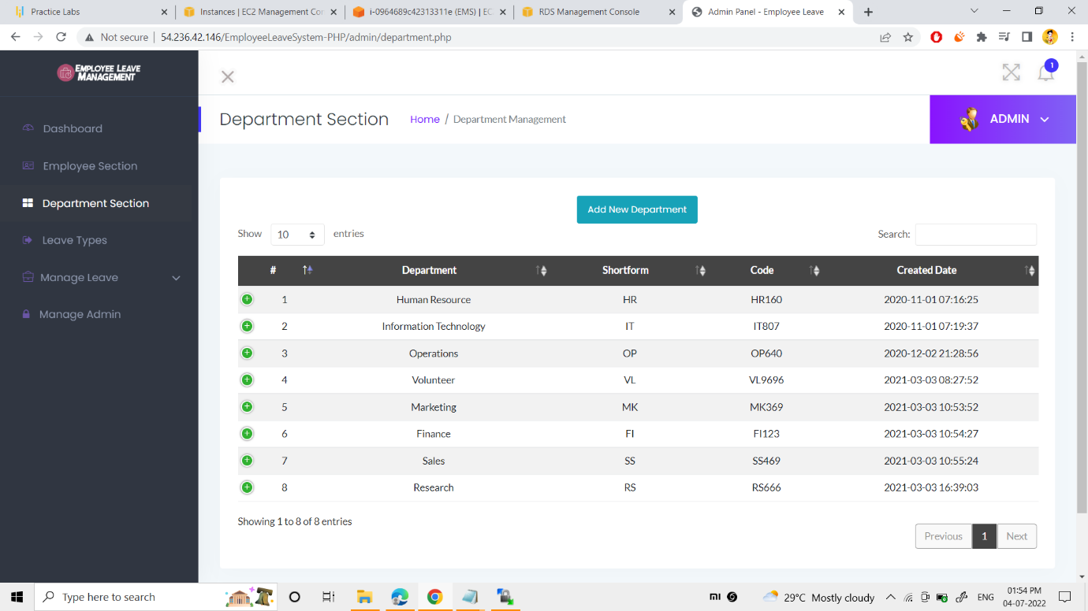

Now, I could add the department section as well as employees also in my originastion.

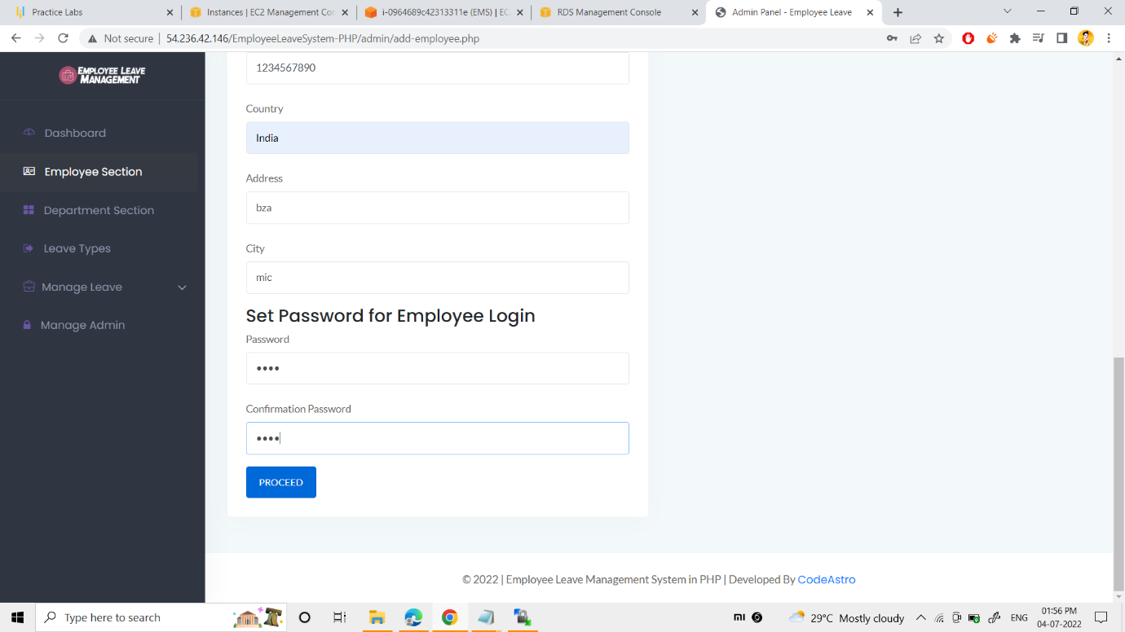

Now you can see creating employee in my org. as an example

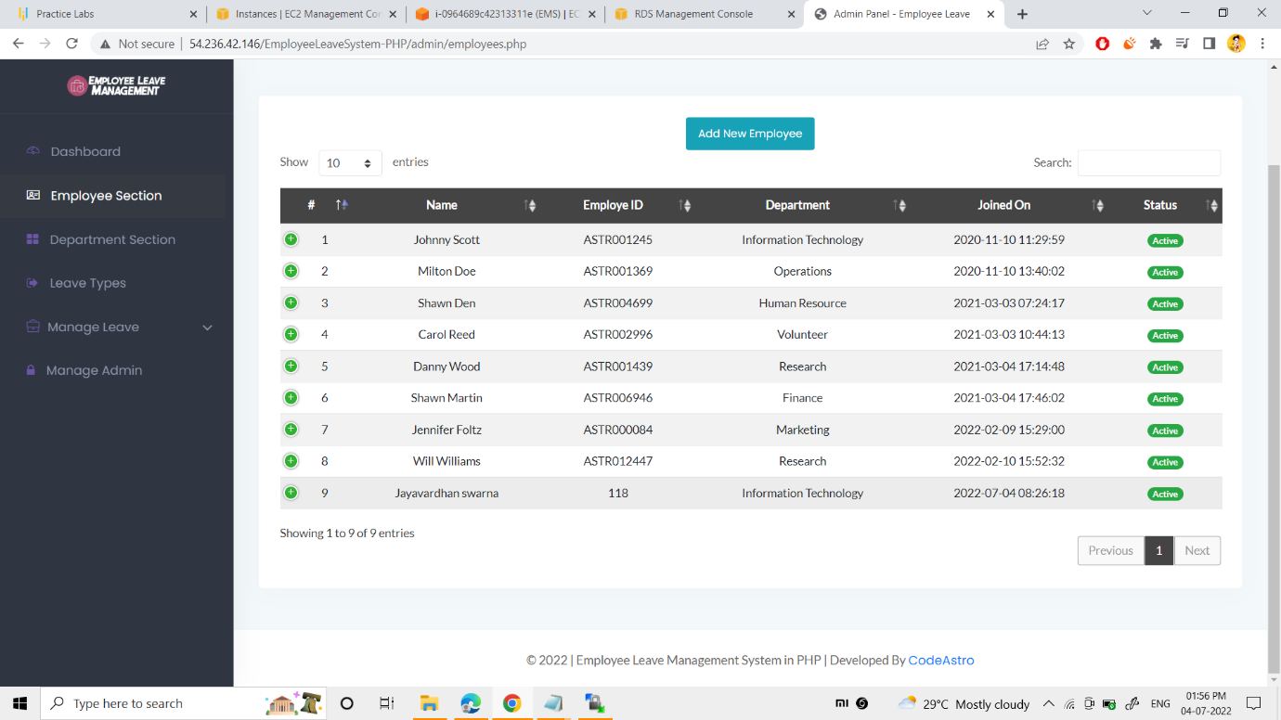

Employee details can be observed as per above snap

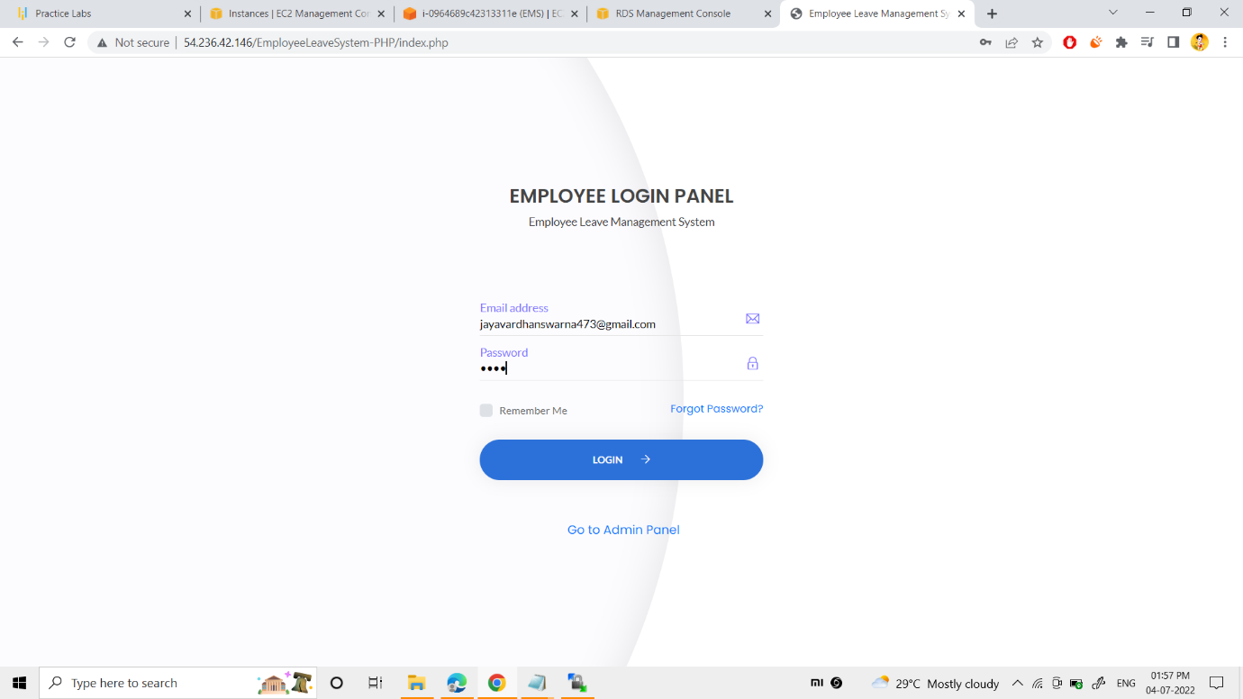

I could also login into the employee console.

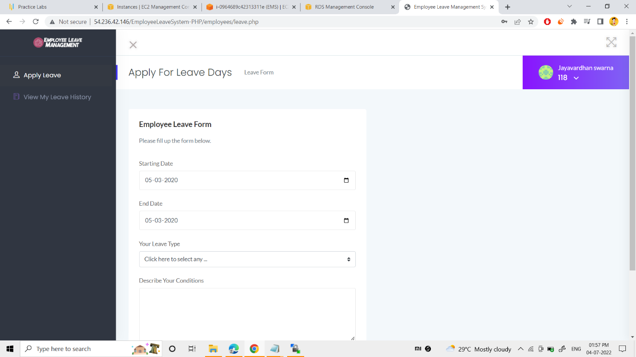

You can see the controls of an employee and their specification.

**AUTOSCALING CONCEPT**

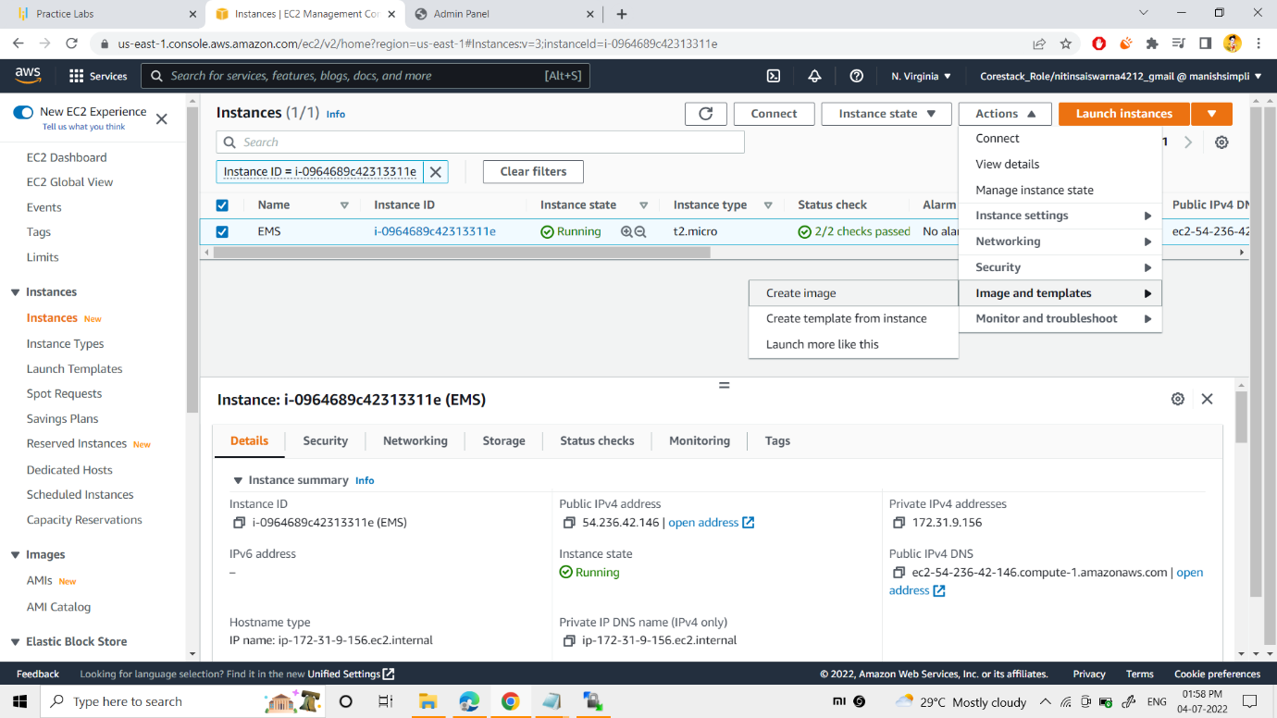

Now, I created an image for my EMS instance as per above snap.

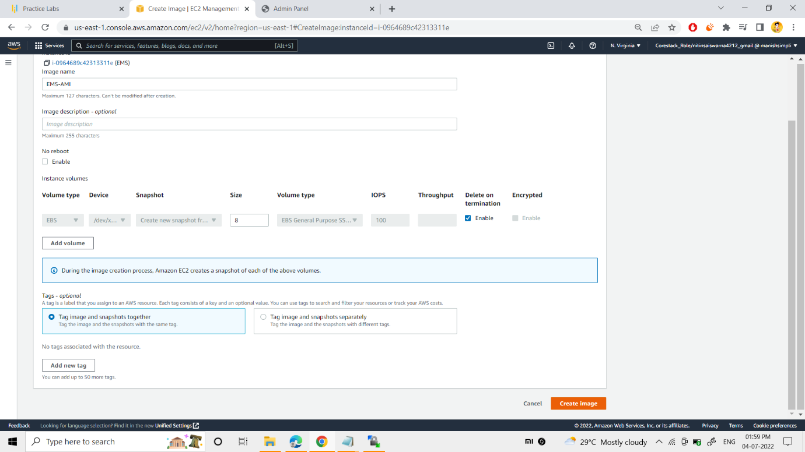

Specified the name to my AMI as “EMS-AMI”

Next I enabled and specified the volume to my EMS-AMI.

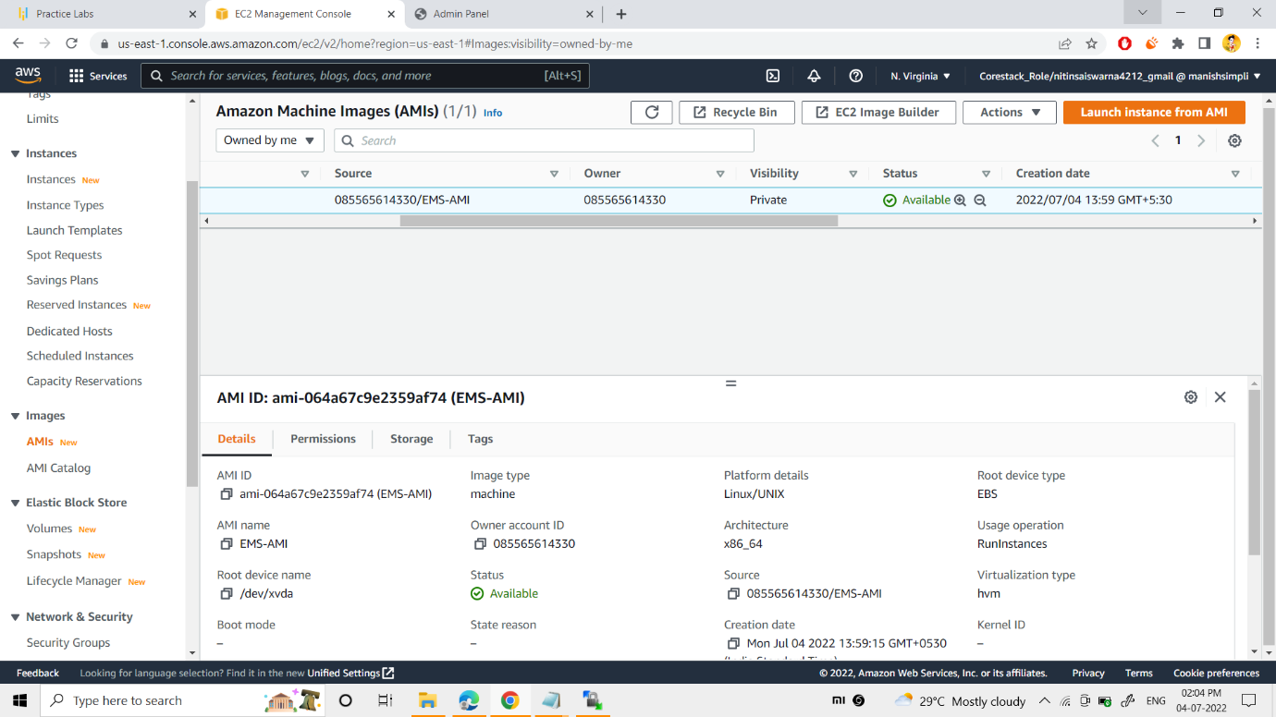

Now, my AMI was succesfully created.

You can also see the details as per above snap.

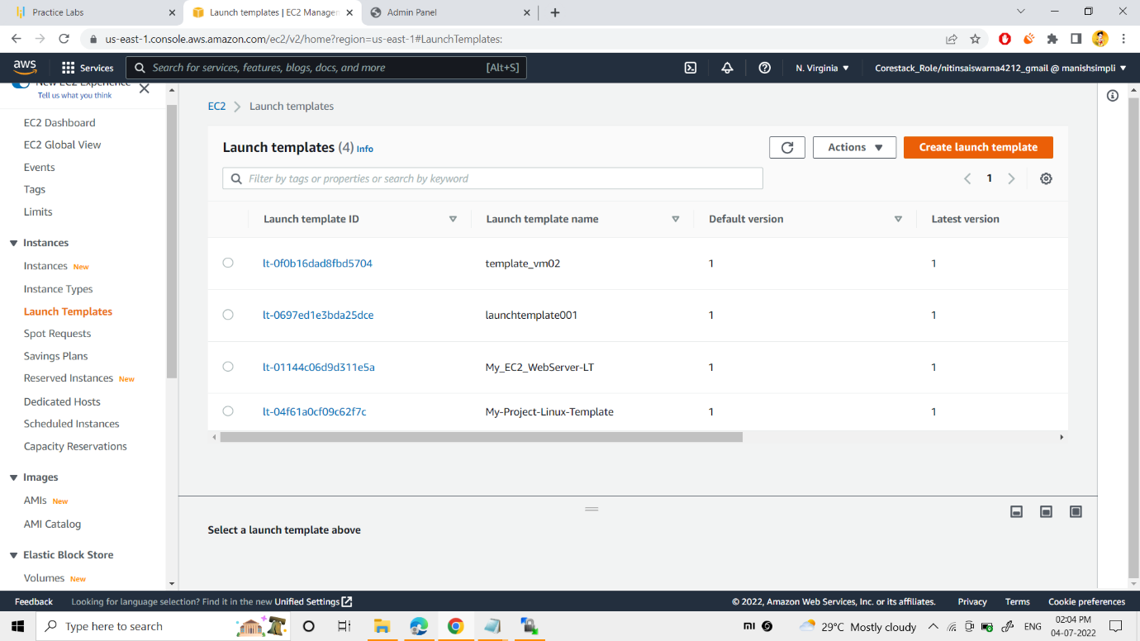

To create the template, “create launch template” button was clicked.

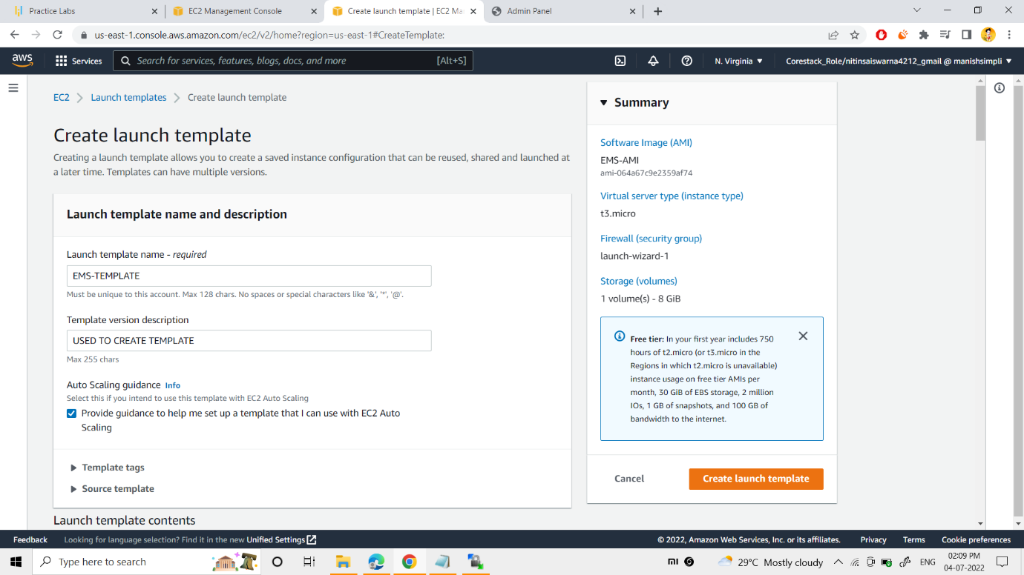

“EMS-TEMPLATE” name was specified to my template.

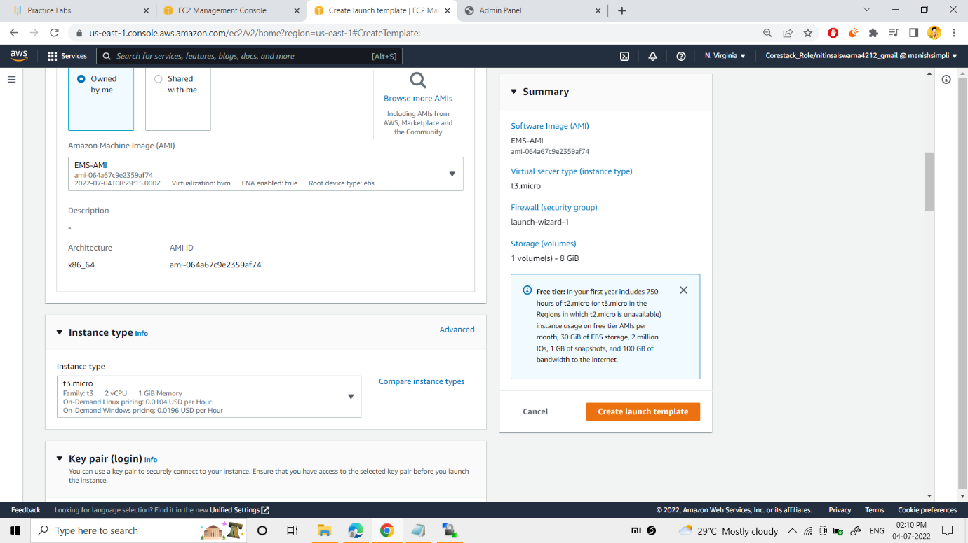

I had selected my created AMI (EMS-AMI) to this template (EMS-TEMPLATE).

“T3.micro” was chosen as instance type as per the instructions given.

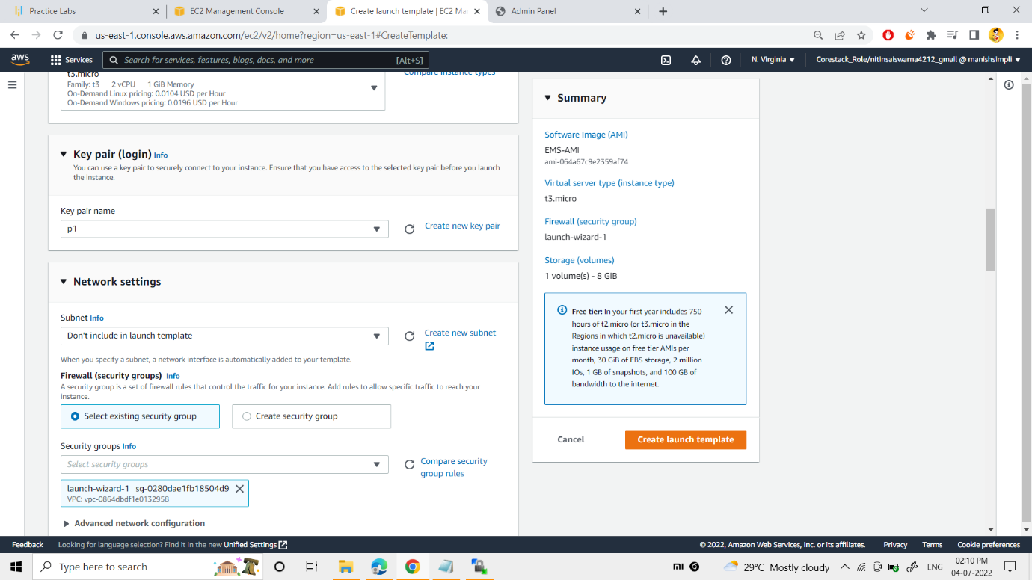

Now, I specified my keypair (p1).

Later on, exisiting security group was chosen as such lauch wizard 1.

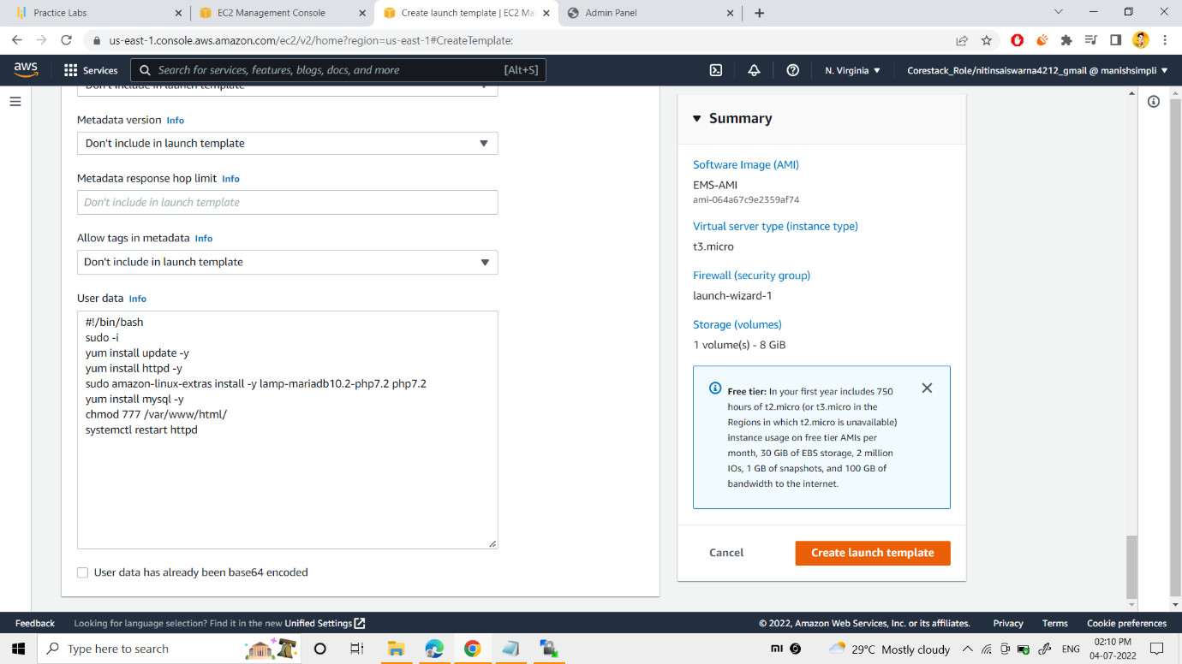

I provided the basic commands to install php, mysql, httpd web server etc.

Finally, I clicked on the “create lauch template” button

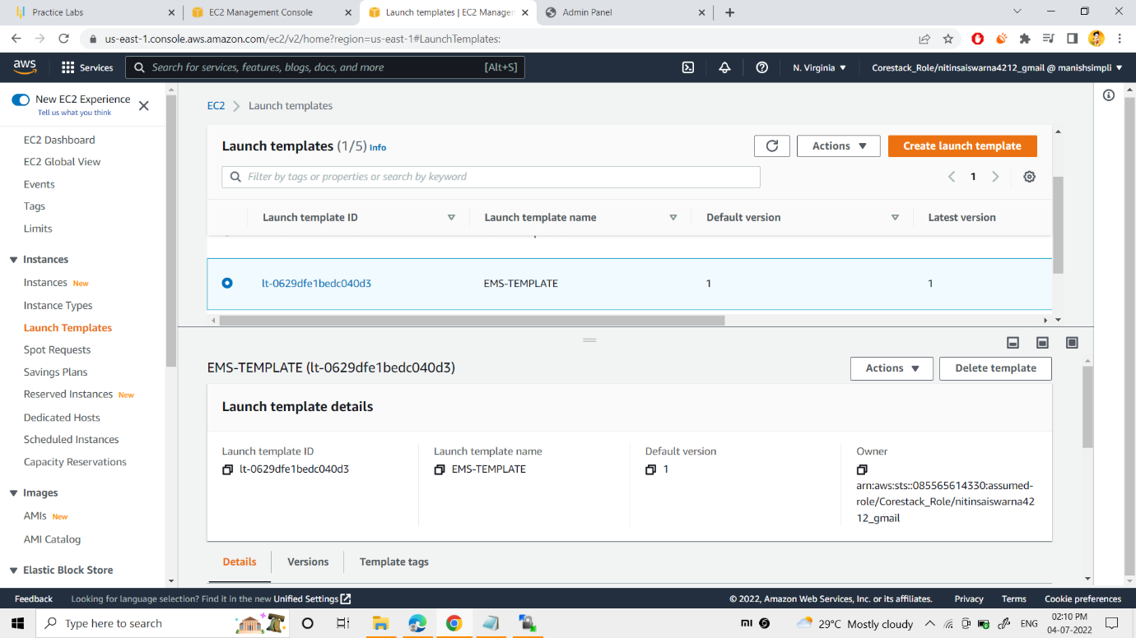

You can see the succesful creation of my template.

you can see the template details.

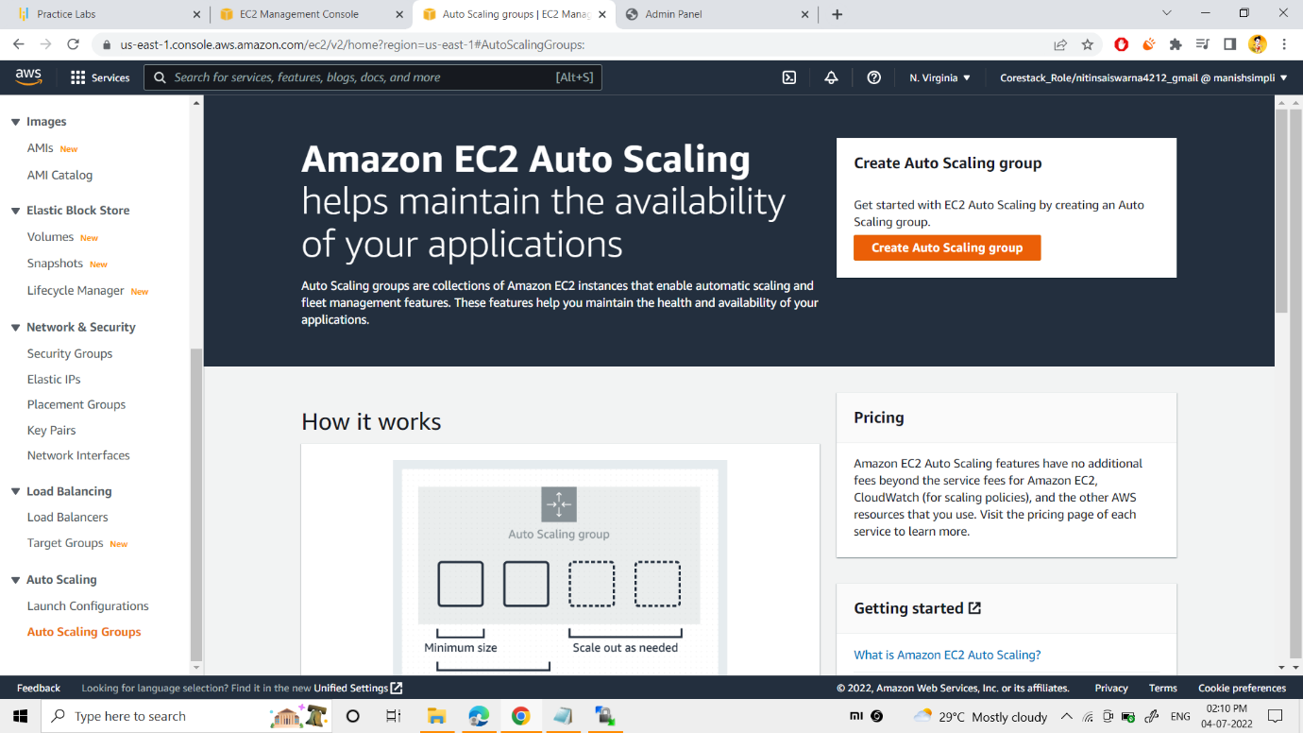

Now I clicked the “CREATE AUTO SCALING GROUPS”, to create the auto scalling to my web server.

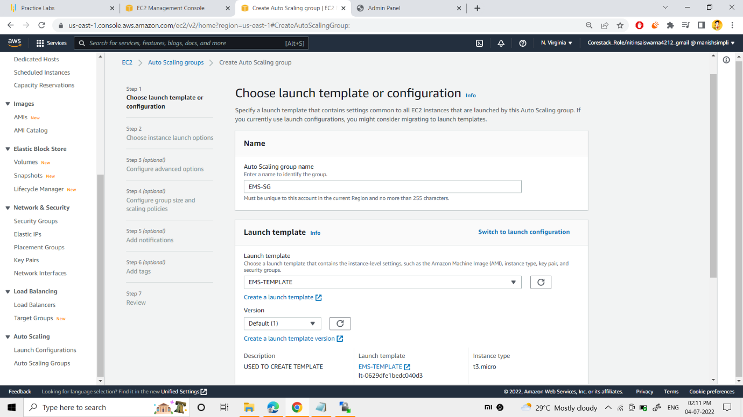

Now Auto scalling group was named as EMS-SG.

Now, I selected my created template(EMS-TEMPLATE) .

Moving to the 2nd step,

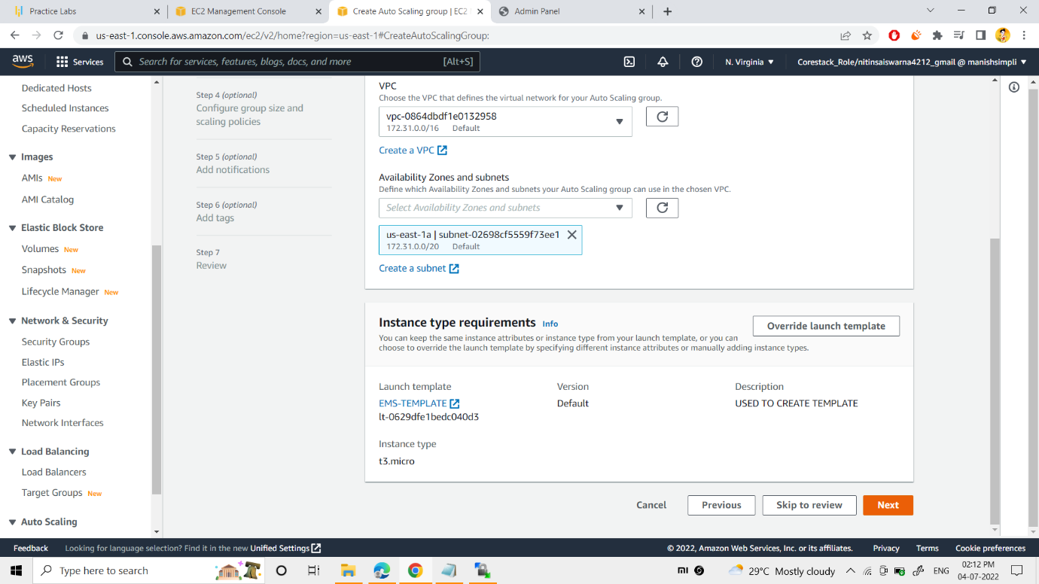

Now, I selected the “default vpc” and my “US-east-1a” subnet

Moving to the 3rd step,

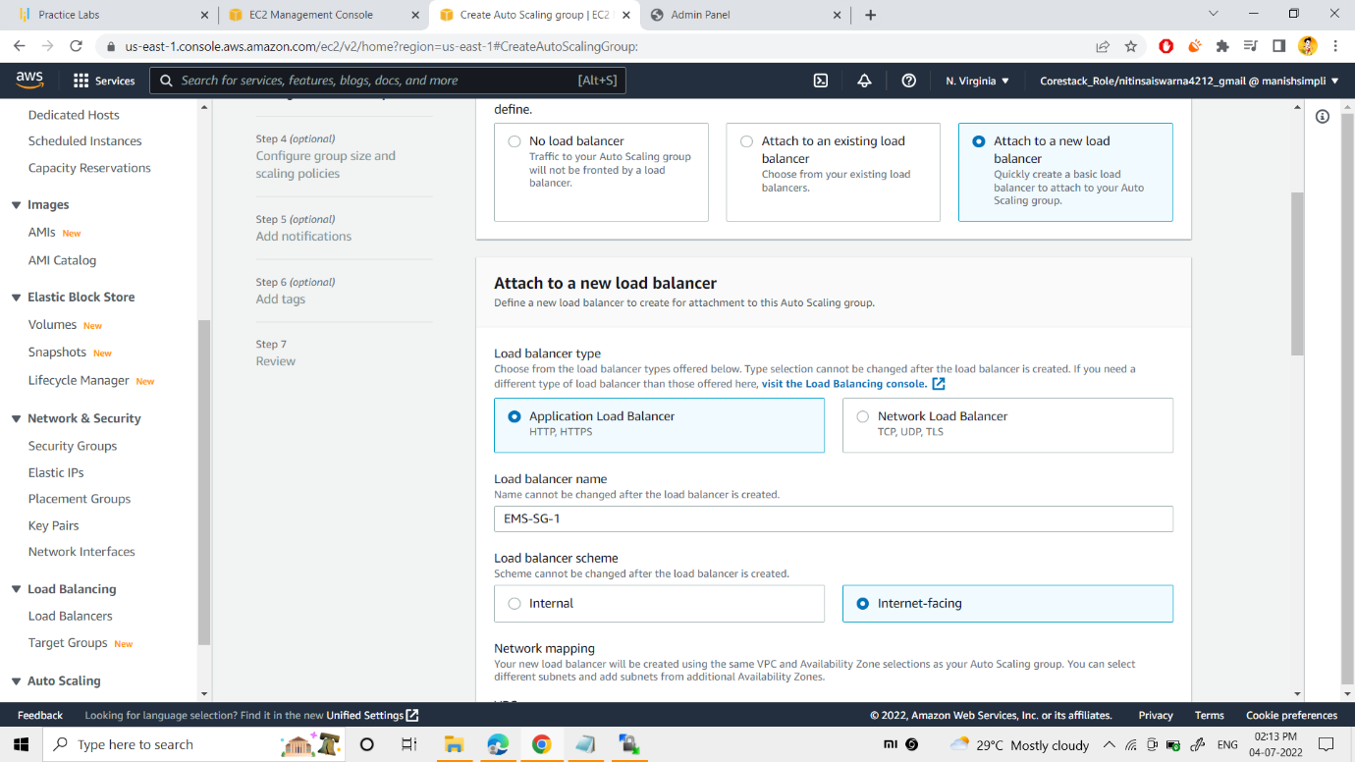

I switched from ”No load balancer” to “Attach a new load balancer”.

And I attached application load balancer and named the load balancer a (EMS-SG-1)

Now I selected the load balancer scheme as “internet facing”.

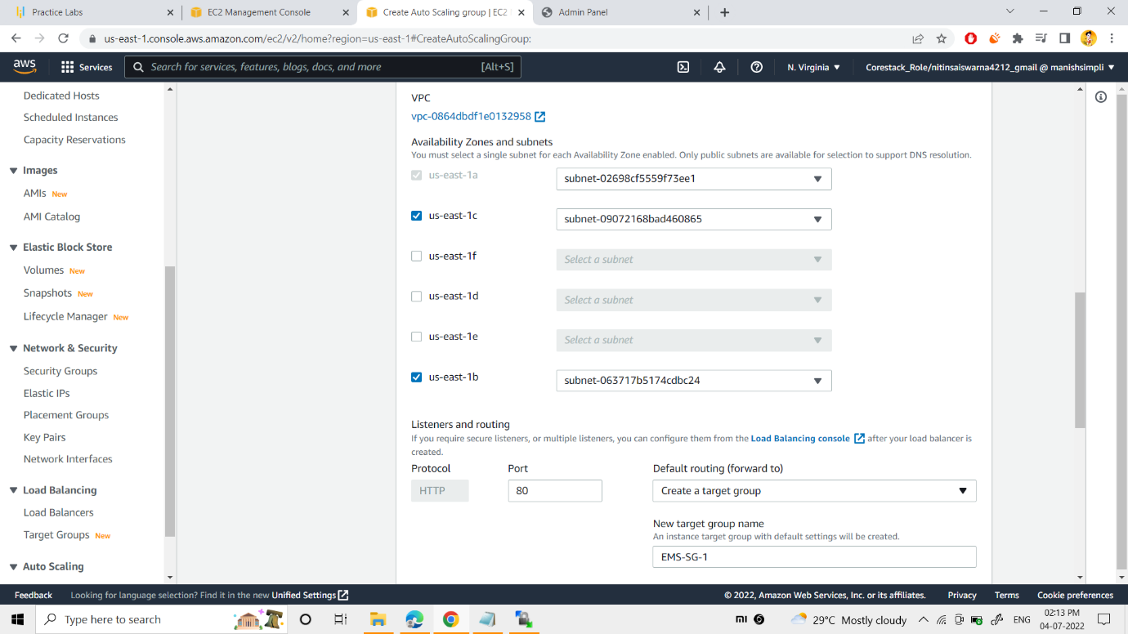

Now, I selected the 2 availability zones as us-east-1c and us-east-1b, as per above snap.

I selected EMS-SG-1 as my default routing.

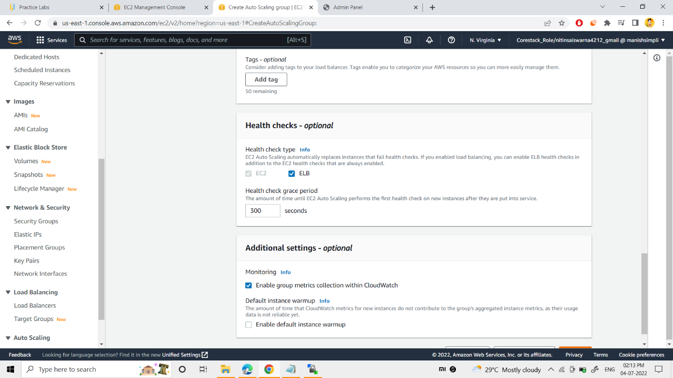

Now I checked ELB as my health check type.

Next I enabled metrics collection within cloudwatch.

Moving to the 4th step,

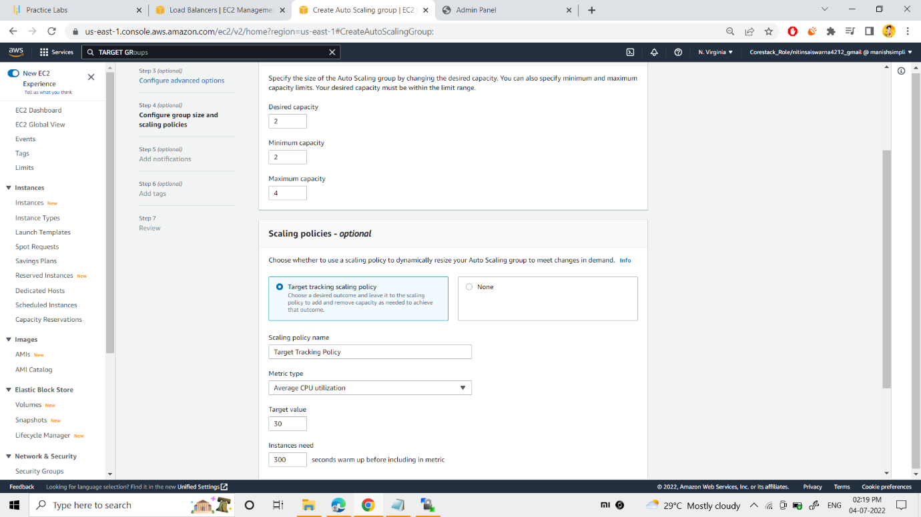

I gave desired capacity:- 2, min capacity:- 2, max capacity:- 4

And I selected the “Target Tracking scaling policy”

30% was given to the “target value” and 300sec for “instances need”.

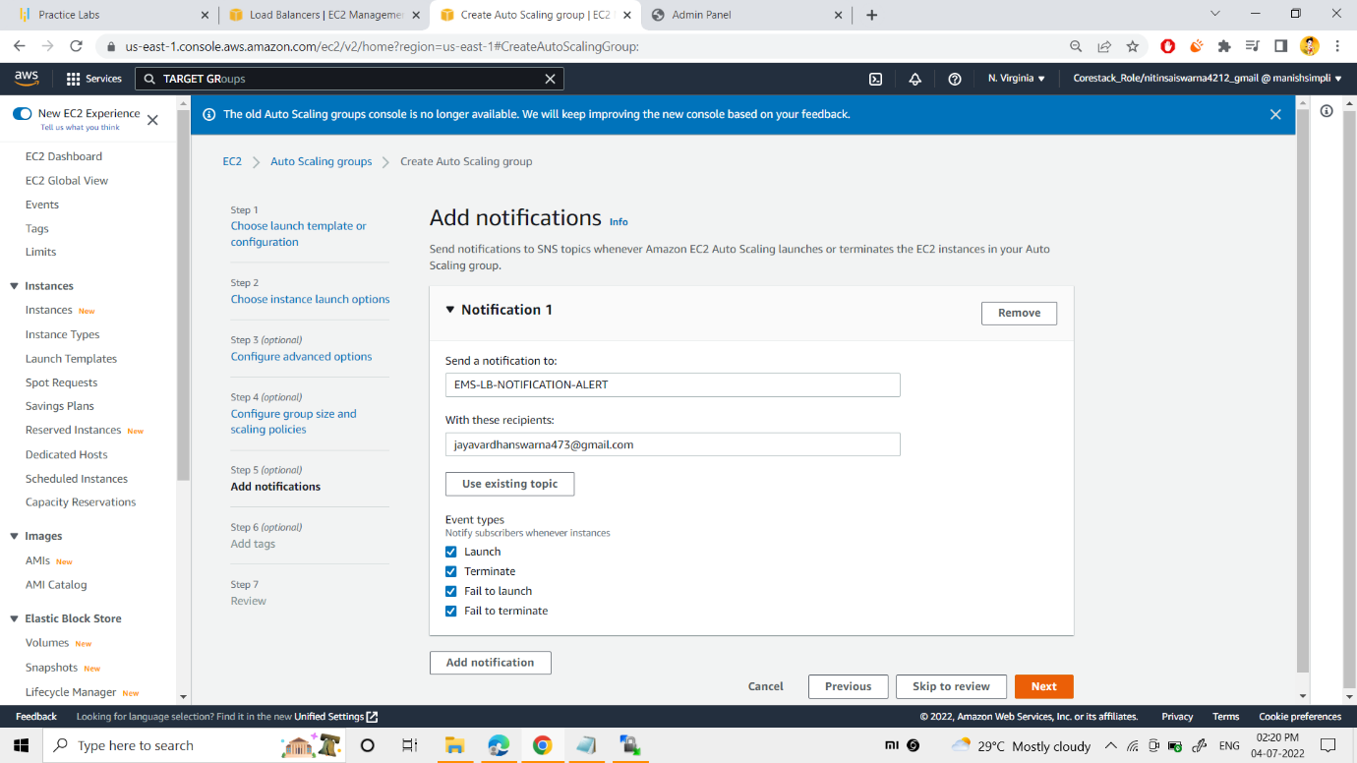

As per above snap, to monitor my autoscaling, I had set up the notifications alert.

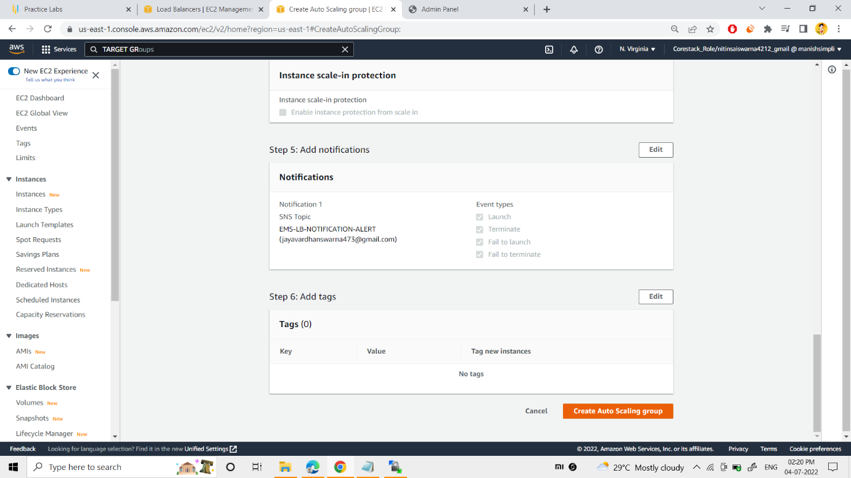

Finally, I reviewed all my settings of auto scaling group and launched the auto scaling.

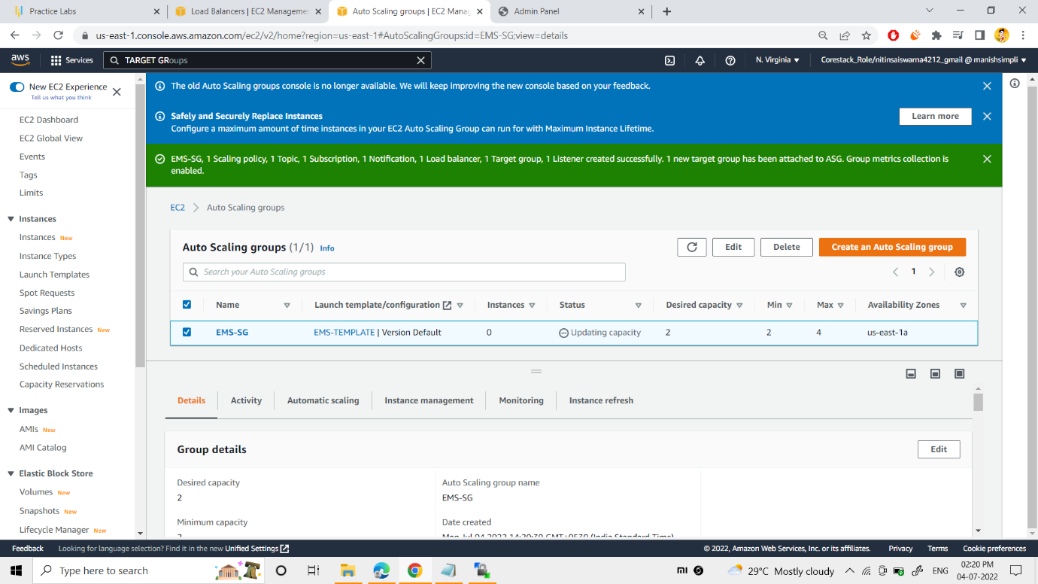

As you can see the sucessful creation of my auto scaling group and its details.

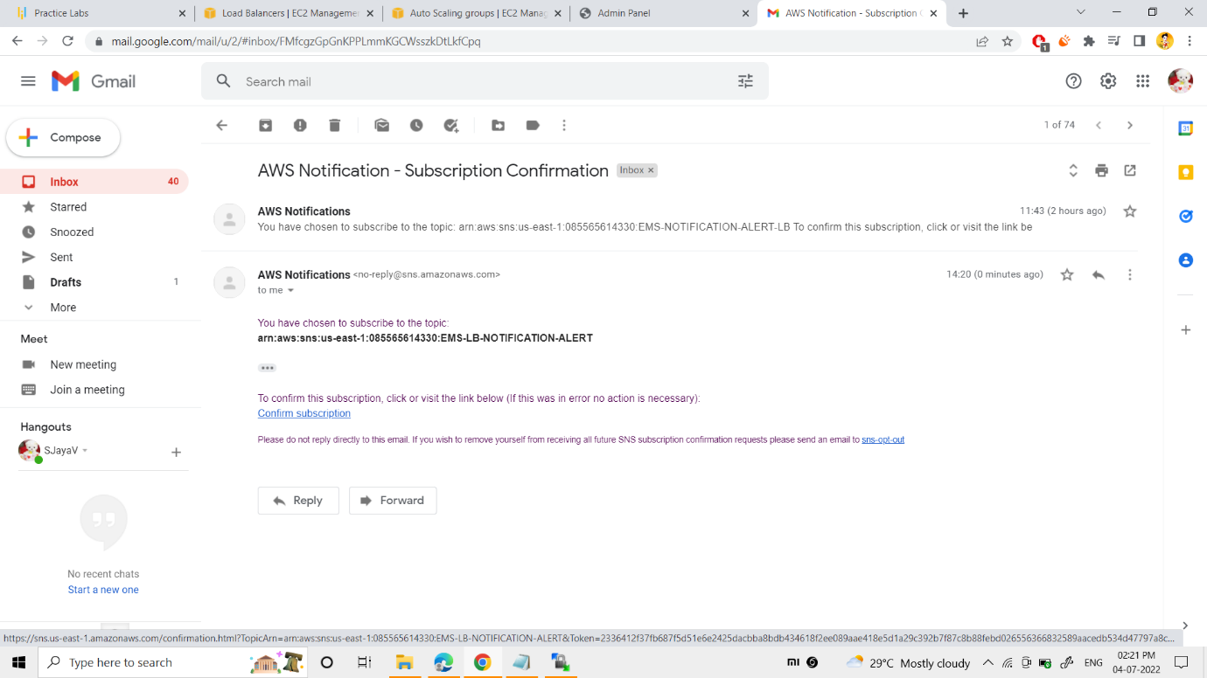

I got the aws notifiction to my email id about “subscription of autoscaling notification”

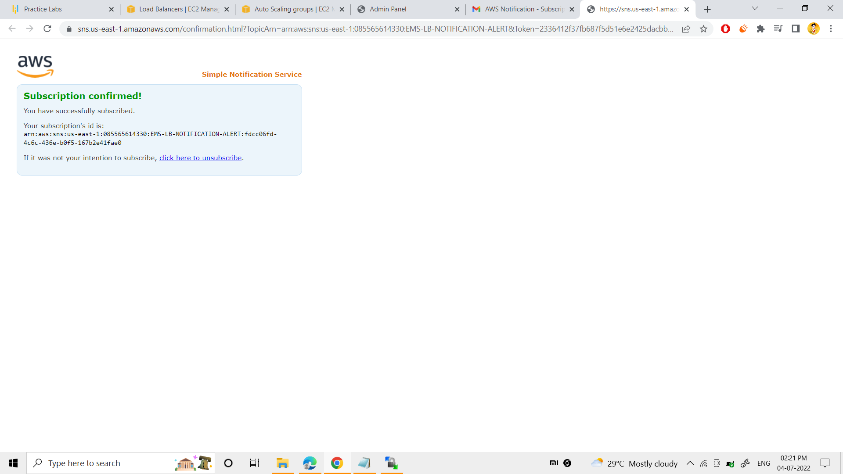

I had subscribed to the sns service.

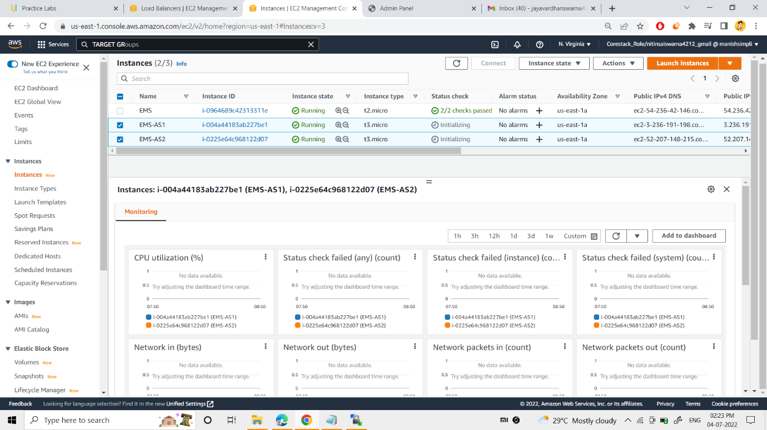

As you can see, EMS-S1 & EMS-S2 servers were launched by auto-scaling itself.

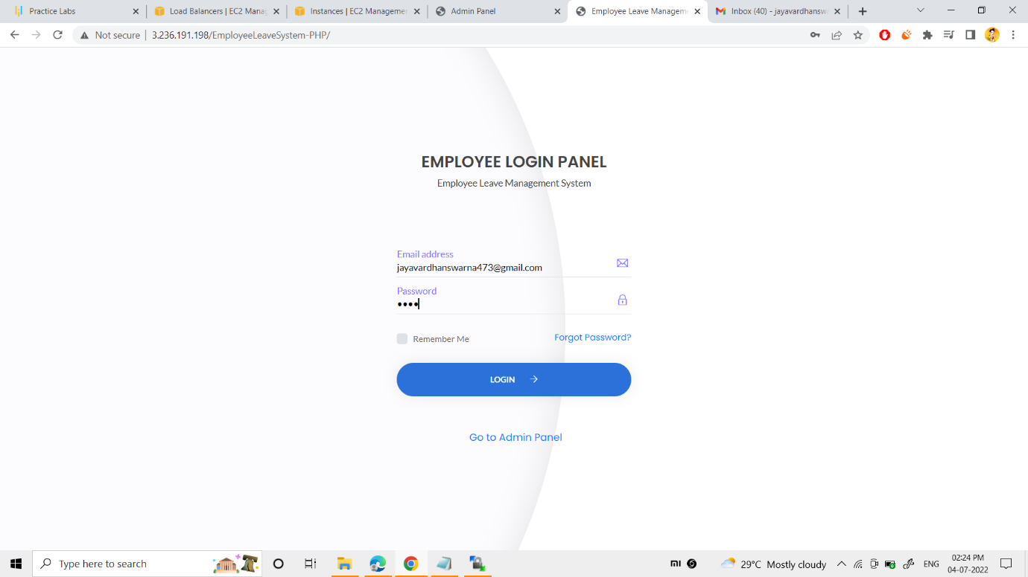

Now I could able to access my website from other server ip address(3.236.191.198) also.

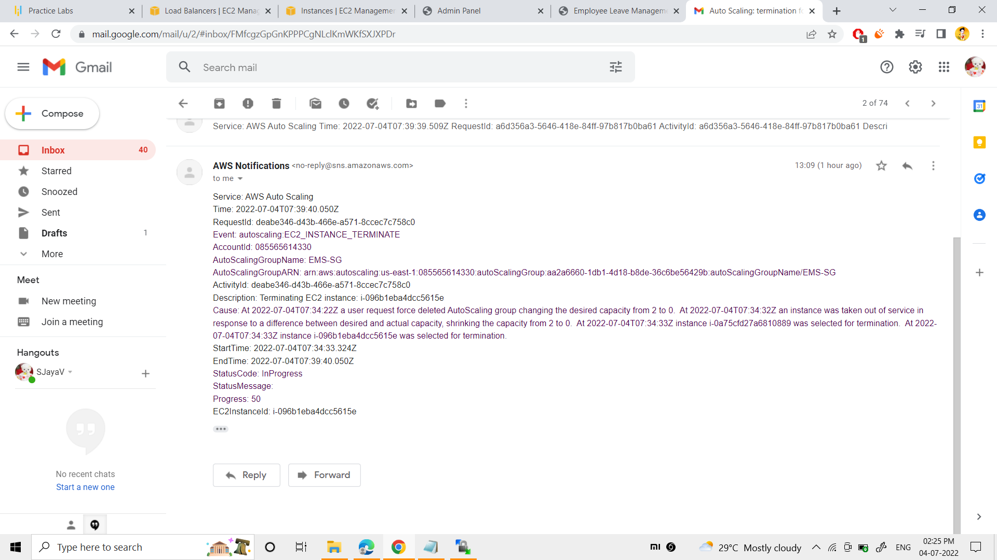

Notification of auto creation of web server by auto-scaling.

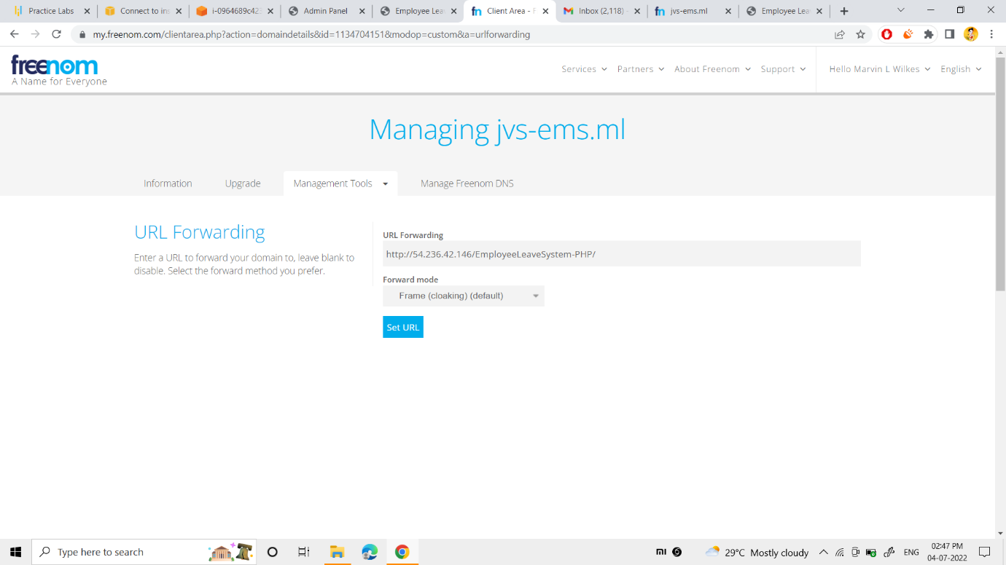

Actually, the domain “jvs-ems.ml” was purchased from the freenom website.

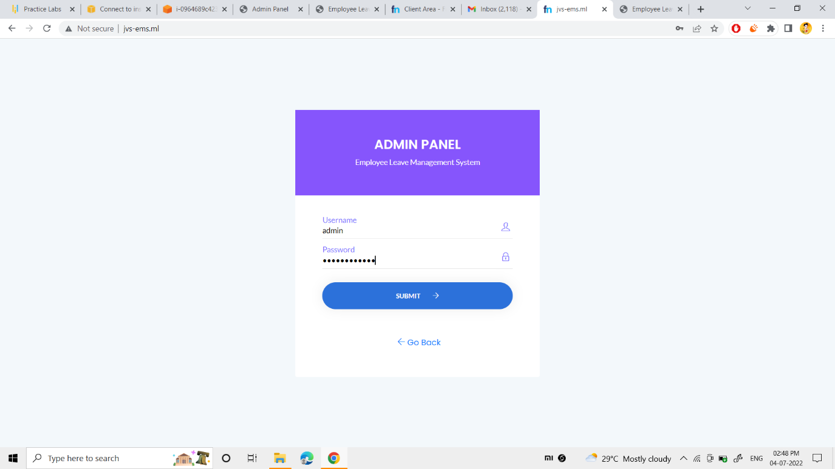

Finally, my domain was working successfully.

Web folder :- <https://github.com/Jayavardhan-swarna/AWS-EMS-P1.git>

**THANKING YOU**